Developing an Artificial Intelligence to combat inaccuracies within the weather forecasting sector

SCDT65 – Individual Project   
PIL17003689

Word Count:

# Contents

Contents 2

Abstract 4

Ethical Approval 5

Introduction 5

Project Definition 5

Project Aim 5

Project Objectives 6

Literary Review 7

The Problem – Inaccuracies within the weather forecasting sector 7

Forecasting Models 7

Existing Solutions 8

Medium Contradictions 9

Existing Solutions 10

Front-end Design and Development 12

Web-Based Philosophies 12

Justification of Tools 15

Front End 15

Back End 16

Methodologies 19

Design Methodologies 19

Software Development Methodologies 20

Software Development Lifecycle 24

Sprint #1 – Initial Design Principles *(6/11/2023)* 24

Requirements 24

Analysis 24

Implementation 25

Summary 27

Sprint #2 – Webpage Development *(4/12/2023)* 28

Requirements 28

Analysis 28

Implementation 28

Summary 30

Sprint #3 – Development of a Flask Solution *(8/1/2024)* 31

Requirements 31

Analysis 31

Implementation 31

Summary 32

Sprint #4 – Data Cleaning and Analysis *(5/2/2024)* 33

Requirements 33

Analysis 33

Implementation 33

Summary 40

Sprint #5 – AI Model Development and Training *(4/3/2024)* 41

Requirements 41

Analysis 41

Implementation 42

Sprint #6 – Deployment *(15/4/2024)* 47

Requirements 47

Analysis 47

Implementation 47

Sprint #7 – User feedback & API handling *(6/5/2024)* 51

Requirements 51

Analysis 51

Implementation 51

Project Evaluations 54

Testing 54

Unit Testing 54

Integration Testing 54

Acceptance Testing 54

Overview 55

Legal, Social, Ethical, Economic and Professional Impact 56

Future Modifications 56

Appendix 57

Test Table 57

References 60

# Abstract

Within the project, an artificial intelligence machine learning model with be developed using the Python programming language. Python’s support for libraries regarding data analysis and machine learning is uncontested regarding programming IDEs.

The dataset will be cleaned using the data analysis tools found within Jupyter Notebook’s libraries; NumPy, Matplotlib and Pandas. These libraries offer a multitude of data cleaning techniques to ensure the dataset is well suited for the AI.

Additionally, libraries with a heavy emphasis on machine learning algorithms, such as SciKit Learn, Pickle and Natural Language Toolkit to name a few will be incorporated to aid in the development of artificial intelligence.

Once the algorithm is finalised, it will need to be hosted on a webpage to be viewed. To achieve this, the micro web framework Flask will be used to run python scripts via a web solution, for example, on a PHP webpage.

# Ethical Approval

During development and testing, no ethical issues involving business or user data will arise. The dedicated dataset revolves solely around publicly available data within the past decade and will not involve any integration of personal information nor user interaction regarding personal data meaning ethical approval is unnecessary.   
Any feedback provided by individual(s) is left anonymous as a respect of privacy. No user data in regards to identification of the user is processed and opinionated data is used with the permission of the user in question. This query abides by the [Data Protection Act of 2018](https://www.gov.uk/data-protection) as to avoid any sensitive personal information.

# Introduction

## Project Definition

In accordance with the Met Office (2020), the average weather forecast within the last decade has been criticised as potentially inaccurate with – on average – each report having an 80% chance to result in accurate predictions. Due to this inaccuracy, there is a 20% chance that a weather report will give false information to its users, resulting in vast user displeasure as said chance of failure can result in a multitude of issues regarding the user’s experience with and outside of the proposed solution.

To combat this, the solution will incorporate a wide dataset of weather forecasts within the past decade including the weather summary, humidity and temperature along with the use of a machine learning algorithm to identify patterns within the dataset and propose accurate predictions on weather forecasts.

Additionally, the web-based solution will provide great accessibility for users on multiple platforms including desktop and mobile devices.

## Project Aim

To develop and display an artificial intelligence that incorporates machine learning algorithms to predict current and future weather forecasts using a dataset through a web-based solution.

## Project Objectives

The project will achieve success through the following of these objectives:

* Commitment onto the literary review of the current topic.
* Data Analysis.
  + Commit to Data Understanding and Data Cleaning, two CRISP-DM phases.
* Design UX and UI.
  + Generate hypothetical user identity to pander design to.
  + Incorporate common web design laws into design i.e., Fitts’ Law.
  + Develop front-end UX and UI designs.
  + Perform Quality Assurance procedures to ensure the web solution is suitable.
    - Unit Testing.
    - Integration Testing.
    - Regression Testing.
    - Usability Testing.
    - Security Testing.
* Develop AI model.
  + Incorporate all CRISP-DM principles when deploying the model.
  + Perform supervised and unsupervised testing to create a model.
  + Supply model with datasets and perform predictions.
* Deploy AI model onto the web-based solution.
  + Incorporate the use of Flask and FastAPI to make the program recognise the AI as an API.
  + Integrate the API into the code using JavaScript.
  + Run continuous testing to ensure the API is fully functional on multiple devices.
* Showcase the software through GitHub repositories along with a server-side web host.
* Project Evaluation.

# Literary Review

## The Problem – Inaccuracies within the weather forecasting sector

### Forecasting Models

The weather forecasting industry sees an incline in efficiency and accuracy with each passing decade as predictions estimate an 80% average accuracy in 2021. (Klinger, K., 2021) This average has allowed predictions to span over a wider time frame. Since the weather itself is somewhat unpredictable, creating a report of estimates will decrease in accuracy the longer the estimation goes on for as it does not account for the current ongoing changes created by abnormalities like storms that would be easier to predict in a shorter time span. (Kealy, J., 2019)

The best theoretical solution would be to create new reports daily to ensure accuracy is at its peak which is what was carried out in the past. However, as the understanding of patterns grows and the incorporation of machine learning algorithms settle within the weather forecasting sector, predictions can occur between longer intervals as prediction models have improved. (Chantry, M., 2023)

One of these advancements within the sector is the Met Office’s Unified Model (2022)   
This model incorporates a hierarchy of configurations from a multitude of data reports from contributor such as the Joint Weather and Climate Research Program to summarise the most optimal weather forecasting results over different timeframes. I.e., A regional report from Euro4 will have a timeframe of 7 days and will cover a 4km distance, whereas a global report from MOGREPS-G will have a timeframe of slightly over 7 days but will cover a 10km distance. *(See Figure 1.)*

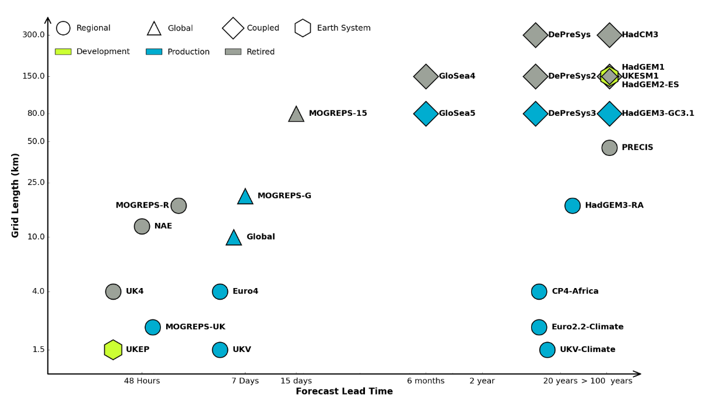

Figure 1: A diagram of the Met Office’s Unified Prediction Model. (2023)

This type of advancement within the sector has seen reports become undoubtably more accurate within the past decade, yet the results still receive criticism.

### Existing Solutions

Conventional weather forecasting methods resulted in moderately accurate results, but Google DeepMind provided recently that these models were severely inefficient. As the world incorporates artificial intelligence into more industries, such advancement is kept behind in the weather forecasting sector.



Source: [Medium.com](https://gordicaleksa.medium.com/how-i-got-a-job-at-deepmind-as-a-research-engineer-without-a-machine-learning-degree-1a45f2a781de)

DeepMind is an AI model made by Google to accurate predict forecasts using patterns that would not be discoverable by human interaction, going on to beat the world’s leading system in 90% of metrics used and taking only a fraction of time. (Cookson, C., 2023) The potential in AI development revolving around the weather forecasting industry has gone on to encourage firms to increase timeframes in which reports can be made, from the standard 5-7 days to 10 days whilst retaining the same accuracy.

DeepMind went further to predict weather anomalies, like Canada’s hurricane Lee 9 days before the event which was record breaking as usual models would have predicted the storm 3 days later. The machine-learning co-ordinator behind the case study at the European Centre for Medium-Range Weather Forecasts – or ECMWF – Matthew Chantry stated that “meteorological AI systems had progressed far sooner and more impressively than we expected even two years ago.” (Lam, R., 2023)

Additionally, associate professor of atmospheric science and hydrology at the University of Arizona, Kim Wood (2024) criticised existing AI solutions in a report to Scientific American, stating that “Because of their reliance on past data, most AI models might be poorly equipped to forecast rare and never-before-seen events.” Wood then proceeded to offer an example in “Hurricane Harvey, which dropped an unprecedented 60 inches of rain on parts of Texas in 2017.” This extremity could not be replicated by the behaviour of an AI as abnormalities akin to this will not be represented well in datasets. Furthermore, such extremities lack any form of long-term pattern recognition to identify these events.

To combat extremities in the past, researchers would identify patterns that would lead to rainfall and heavy storms by using short-range forecasts of 1 day, or sometimes less than a day, to improve accuracy tenfold (NOAA, 2021). These short-term forecasts will help researchers in spotting leads to an anomaly in the weather forecast and act upon it with haste. Such a practice is uncapable with unsupervised machine learning models and would instead force the idea of supervised classification or regression upon researchers when developing a model.

Concluding that artificial intelligence and machine learning, even within the past 5 years, had provided such an overwhelming advancement to weather forecasting despite few firms moving over to the new phenomenon and sticking to old mediums.

Though the model behind forecasting is not the only outdated problem within the industry, but also how data is presented.

### Medium Contradictions

A report from the BBC’s meteorologist, Nick Miller (2020) suggests that forecasting firms will not always report the same findings, stating; “If there is a 30% chance of a shower, one app might choose to show a shower symbol whereas another picks a partly cloudy symbol because there is a 70% chance it will stay dry.” Which brings up the lack of proper information displaying from firms within the sector.

This is due to medium of the forecast, where a user viewing the information on an app will tend to want faster data to intake that those on a television or desktop. A study conducted by the University of Alberta discovered that reading comprehension was impaired when content was presented on a mobile-size screen versus a larger computer screen. (Moran, K., 2016) This is due to the smaller text size and character amount in the smaller screen resolutions, so to combat this, apps will tend to focus more towards presenting bigger images or smaller data to the reader, making it easier to read.

When directly comparing the human brain’s ability to process data between images and text, according to The Media Education Centre (2010), we as humans process visuals 60,000 times faster than text, increasing the appeal of image-based sources due to the comprehensibility of the medium over a text-based solution. Furthermore, web publishers, on average, take in 12 times faster internet traffic growth due to their visual content than the average text-based web domain. (Alexis, C., 2018) This can be backed up by a study conducted by Brightcove Marketing that discovered that 95% of all respondents preferred image and video format over the typical text-based solution. (Kashyap, K., 2022)

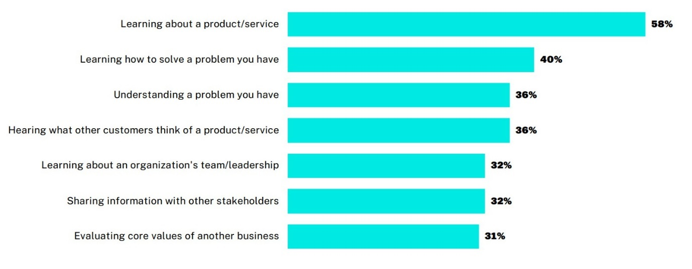

Figure 2: A visual display of how videos are most helpful when making a purchase decision.   
(Brightcove, 2022)

Figure 2 refers to how the respondents regarded the importance of video when displaying information with the most important factor being learning about the product/service at 58% with the second most important being learning how to remedy the problem that the product aims to solve at 40%.

With all of this in mind, the use of visual stimulus means that data is typically limited as to retain the user’s attention and, as per the previous example provided by Nick Miller, the implementation of imagery or video within the weather forecasting industry can obscure data to fit a graphic’s requirements, I.e., a firm that wants to display a 30% chance of shower as solely an image will tend to lean more towards the partly cloudy symbol as to use as little content as possible to display the information, whereas a more accurate reading by another firm may include text and other less visually appealing graphics to display more accurate information, overall losing out on user attention but displaying more accurate information.

### Existing Solutions

To combat this issue between offering accurate information and keeping viewer retention rates high to stimulate more traffic, a middleman must be met to fulfil both purposes.

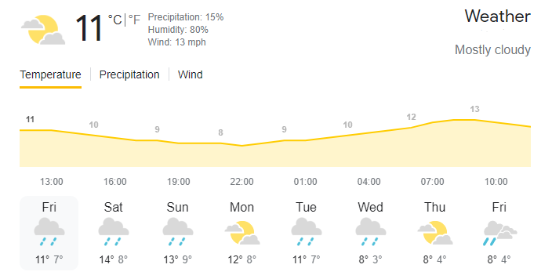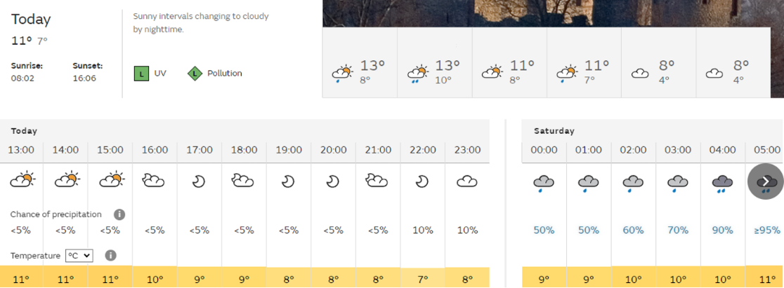

Figures 3 and 4: Weather forecasts provided by Weather.com (3) and The Met Office (4).

These are two examples of successful weather report formats that are used today. Figure 3 follows a visual hierarchy regarding its layout, being the image in the top left and the chart in the middle. These two sets of data provide the user with a rough estimate of the forecast in the use of an image, the current temperature and a predictive chart regarding how the temperature will change throughout the day. Additionally, past and future weather forecasts are provided in a list at the bottom of the graphic with the same data as those in the visual hierarchy.

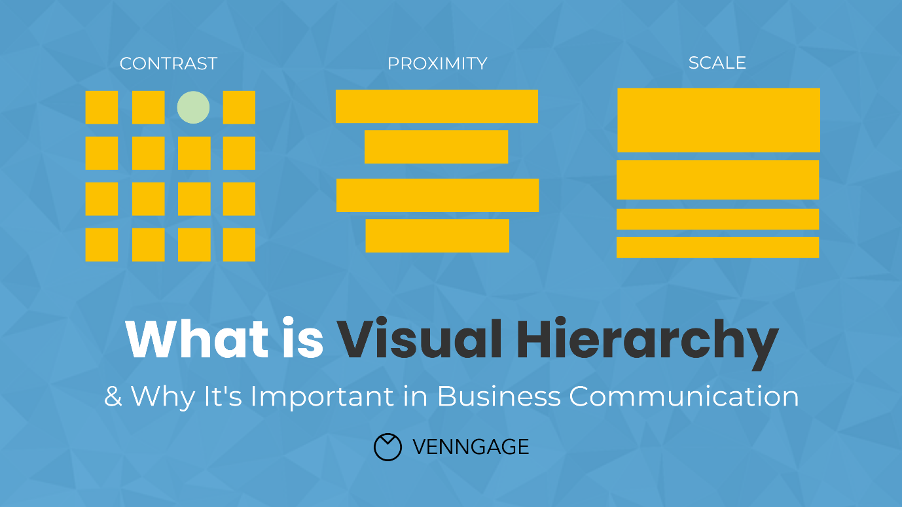

Figure 5: A representation of visual hierarchies. (Gaskin, J., 2022)

Figure 5 refers to the principles of a visual hierarchy, being; contrast – the identification of importance based on colour difference – proximity – the alignment of the content to represent how information is grouped together – and scale – the importance of the information reflected by how easy it is to see.

Judging by these measures, it is visible that Weather.com follows all three principles; the contrast between the image and chart being yellow in comparison to the black and white of the rest of the screen makes them stand out more, the proximity of the data fits as each day’s icon is allotted with information about what is forecasted, and the scale of the current day’s information is greater than every other day, with the icon and chart being the biggest which grabs the user’s attention.

However, sufficient data isn’t properly formatted in a quick and easy way for a user to see. In Figure 3, information regarding humidity, precipitation and wind speed is small and harder to see with the font colouring along with there is no information regarding aspects like the chance of rain or other details people may want to see leaving their interpretations down to an image which refers to the initial problem.

Figure 4 is another weather forecast provided by the Met Office. This figure provides a plethora of information that figure 3 lacks, including weather patterns during the day and UV and pollution levels. However, said figure does not abide by common web design laws, one of which being Fitt’s Law. This law indicates that the time taken to perform an action is dictated by the distance and size of the target object, making decisions slower if the target is small and far away and faster if the target is bigger and close by. (Guiard, Y., 2011)

Regarding figure 4, the data is relatively small and somewhat hard to see due to its size as well as the intractable buttons being relatively small compared to figure 3. The Met Office’s design focuses more on supplying the user with a wide assortment of information whereas Weather.com’s design focuses more on user intractability and ease of use, where one design succeeds, the other falls.

## Front-end Design and Development

### Web-Based Philosophies

As the project will take base on a web-based solution, the use of UX and UI design principles will improve user experience and boost the quality of the webpage. Such laws to follow consist of:

#### Fitts’ Law

A design law that states that the time required to move to a target is a function of the distance to the target and the size of the target (Laja, P., 2022). This relates to the relevance of an object being denoted to how easy it is to access. For example, a best-selling product on a shopping website will be displayed at the forefront of the webpage, making it the most interactable object the user can see, influencing their choice to interact with it.

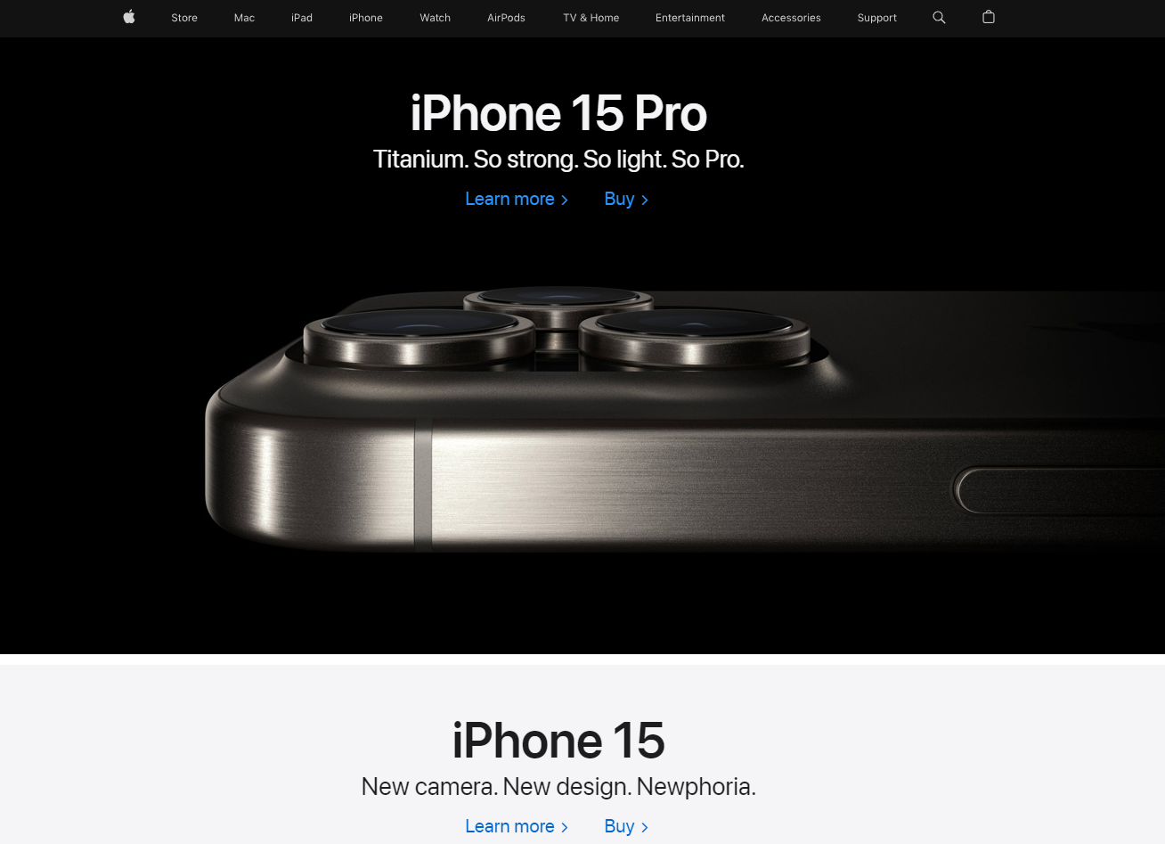

Source: [Apple.com](https://www.apple.com/uk/)

In the Apple website’s index lies an immediate presentation of their latest product, displayed in a majority of the screen, making it the most eye-catching object on the page. This example follows Fitts’ Law perfectly as the biggest and easiest to access target on the webpage is also the most important. Apple’s main incentive is to sell their latest product, so displaying it this way and following this design philosophy will achieve that goal more-so than if it was ignored.

#### Hick’s Law

Hick’s Law refers to the number of possible decisions equating to the time taken to decide. (Lavery, T., 2017) In this instance, if a web solution had multiple buttons within a singular navbar, the user’s choice to click on one would be amplified by the number of options available.

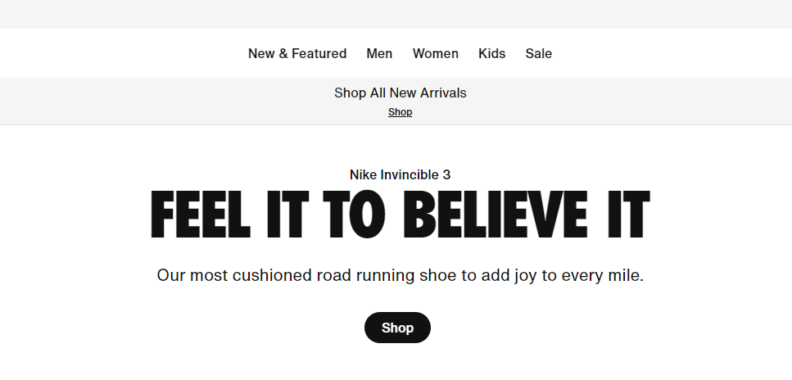

Source: [Nike.com](https://www.nike.com/gb/)

For example, the navigation bar of the NIKE website is minimalistic, providing enough options to fit the average viewer but also not overwhelming said viewer with variety within the first viewing of the website. Additionally, the focal-point of the page consists of the brand’s slogan long with a “Shop” button. As this button remains the only button on the webpage aside from the navbar, it fits the importance of Hick’s Law perfectly, being the only option, the viewer has, decreasing decision making time and overall increasing the efficiency of browsing the Nike online shop, which is the primary focus of the webpage.

#### Visual Hierarchy

The Visual Hierarchy refers to the importance of content depending on how much it catches the user’s eye. This can be done through size, colour and contrast. (Gordon, K., 2021)

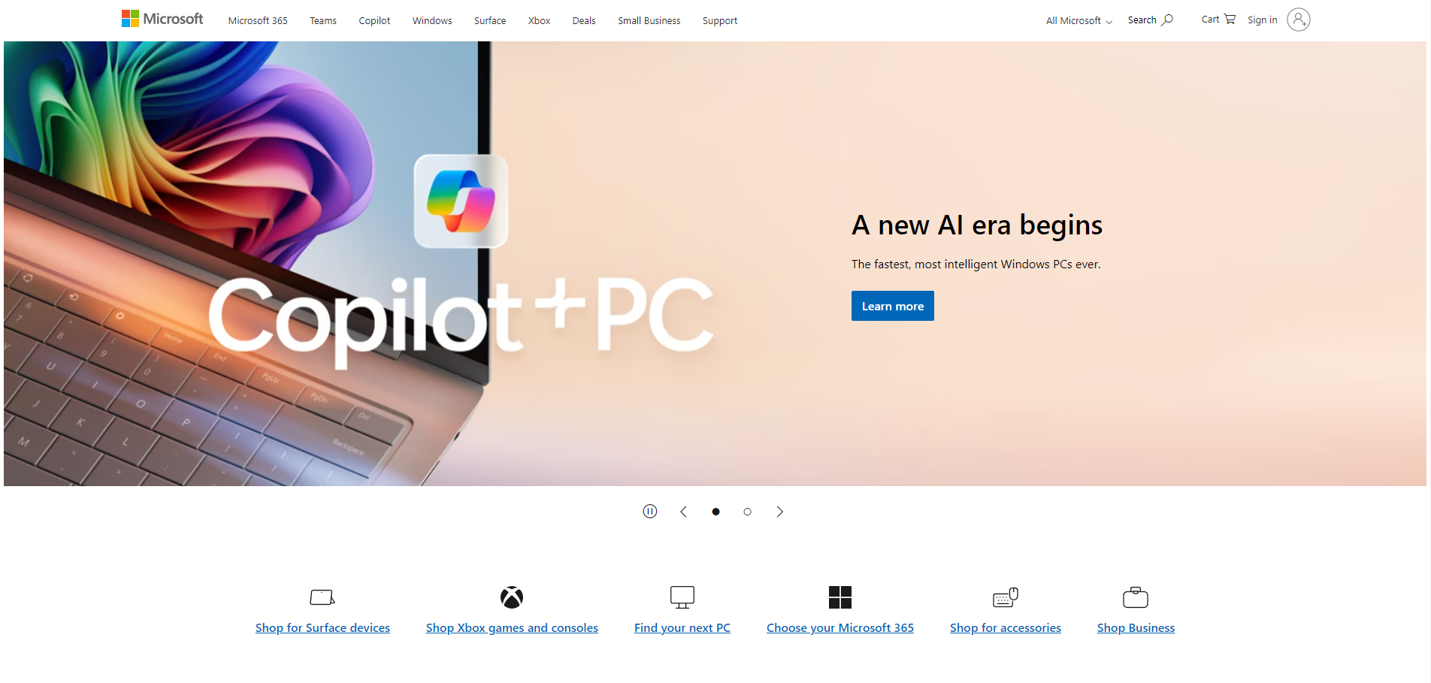

Source: [Microsoft.com](https://www.microsoft.com/en-gb)

In the exemplar Microsoft home page, the page consists of a white background with black text and images. These components already stand out as they have a high contrast to the background, however, the consistency of them lowers this by making each component less unique.

The main focus on carousel in the centre. By enlarging the carousel to fit the majority of the page while using colours that do not show anywhere else on the page, the component stands out greatly and reaches the top of the visual hierarchy.

Along with other web-design philosophies, with these in mind, the application can pursue a visually appealing and meaningful design that will appease all of these laws.

## Justification of Tools

### Front End

#### The use of Flask

To ensure the best experience for AI integration, the flask Python library was used for front-end deployment. This framework’s integration within Python makes it a flexible tool for communication between front end HTML and React pages and back-end Python files. (Sen, S., 2024)

Flask’s nature as a Python library also means it has access to the same libraries used when making the model, such as PyTorch and NumPy. These libraries allow for prediction making within the flask page and additional modifications of the model to ensure full compatibility with the front-end, a feature that is unpresented in other alternates. (Borges, P., 2018)

Though Flask is not the only Python web framework. With over 5,000 reported GitHub developers more than Flask in 2022 (Willig, G., 2022), Django is a valid alternative.

When comparing the two directly, Flask offers more variety within both flexibility and requirements when programming while Django is more focused and has prerequisites inline to aid in making a clean project. (Mashutin, D., 2023)

This means that each tool’s effective differentiates with the goals of the project. Where Django offers a more stylistic approach, allowing rich designs to be deployed easily through its inbuilt features templates and layouts while still offering back-end support, (Bahgat, A., 2023) Flask focuses more on providing in depth libraries and allowing the user to create their program themselves with the vast spam of accessible tools.

Both languages find themselves being used in the real world. For example, Flask’s most prominent backers consist of Reddit, Netflix and Mozilla. The Python library allows for scalable microservices that aid in the companies incorporation of management and optimization through decision based matching, pricing and positioning. (Patodi, R., 2023) (Mitrofanskiy, K., 2024) While Django is incorporated into services such as Instagram, Pinterest and Spotify for its higher speed user input processing and inbuilt request methods. (Pandey, B., 2023) (Kugell, A., 2021) Indicating that Flask is prioritised by brands that prioritise fast paced back end responses and vast libraries with little user input while Django is used more for faster speed user input processing. (Great Learning, 2024)

With this in mind, the usability for each language relates back to the project. Within this project, the use of Flask is opted for the vaster span of libraries and additional back-end support over Django’s simplicity in design and creation over being more limited.

### Back End

#### Programming Language and IDE

For the project, Python found itself being the obvious choice of programming language when it came to developing a machine learning algorithm. Being critiqued as the most supportive of programming languages in the terms of machine learning development in accordance with IBM’s Tin Kam Ho (2019) and Telangana’s professor of computer science Srinath. (2017)

When validating which programming language to carry out the project with, it is crucial to include the context of the project within the conclusion. In this case, a direct comparison of IDEs can be made between Python and .NET during the justification of programming languages.

Python offers a vast number of libraries that can be used during the development and deployment of a machine learning model (Stančin, I., 2019), such libraries include; NumPy, which specialises in the optimisation of datasets, formatting them into arrays. The process of doing so speeds up the pre-processing of data within the data understanding and preparation phases of the CRISP data mining model and allows pre-processing functions to more effectively access the data due to the compact nature of an array, meaning less memory is allocated to storing the data, thus making such practices faster and less memory intensive. (NumPy, 2022) SciPy, which is an open-sourced library built off of NumPy that incorporates machine learning models into Python. These models consist of – but are not limited to - random forest, logistic regression and linear regression algorithms. (Virtanen, P., 2020) SciPy also offers sub packages that that specialises in the optimisation of models and error defining such as .optimize and .signal respectively. (SciPy, 2024) Finally, PyTorch is a third library within Python that offers tools regarding deep learning neural networking. These algorithms are used within high-level data management and wide-span projects. (Subramanian, 2018)

Many claims have conducted that Python is the best programming language in terms of compatibility when developing a machine learning algorithm (Muhammad, A., 2023). However, these claims can be contested, as Python retains vital downsides. Such disadvantages include a lack of universal back-end support

These libraries make Python a compatible programming language for a multitude of project types, spanning from big to small. However, this IDE still retains disadvantages. Such cons include a lack of official environment support within the context of the overarching brand. A feature that is greatly praised by its competitor, .NET (Choudhary, B., 2023).

.NET is a cross platform, open source application IDE produced by Microsoft (Regio, C., 2023), this means that it has full compatibility other Microsoft products. .NET excels with deploying windows-based applications and facilitates its machine learning library, ML.NET. The ability to co-operate with tools such as Unity and Tizen along with having inbuilt tools to make accessibility options, ML.NET makes itself a prominent option for developers.

These examples of .NET being used include SigParser, an email service that automatically generates and distributes non-human mail such as newsletters, sign up forms and password reset emails to those using the system. (Microsoft, 2013)

.NET also provides much more in-depth analysis and feedback when error handling, along with better performance along with performance diagnostics. This is achieved through .NET’s incorporation of just-in-time compilation within their IDE. JIT consists of the compiling – or translating of code to machine code – of the program being executed during the program’s runtime rather than before. (Aycock, J., 2003) This leans towards faster load times as the avoidance of compiling the entire application upon running means that compiling is reserved for when areas of code are called to be executed, contrarily increasing load time as areas within the program will need to be compiled when called whereas Python does not require anymore compilation after its initial batch, but this is negated by the fact that not all elements within an application will be used by a user, thus JIT ignores compiling areas of the program that would be unneeded to be compiled.

Ultimately, .NET’s better performance and support from other Microsoft products make it a valid choice when opting for a programming language in ML.NET. However, Python’s vast libraries and accessibility, with the likes of Jupyter allowing for easily executable model creations, avoiding the process of running an entire program and instead opting to execution certain factors of it, makes it the best choice for this project.

The justification behind this decision being that, although the features ML.NET provides are great, they are not as applicable in the context of the project as Python’s libraries. The support from other Microsoft products is useful for app development within Windows, though the nature of the project being a webpage makes this point redundant.

After the proposal of a programming language, the environment in which to develop on is the next factor to assess, two of the most popular IDEs in regards to machine learning development are PyCharm and Visual Studio Code, both of which support the Python programming language.

To begin with, a difference between PyCharm and Visual Studio Code – now being referred to as VSCode – is the nature of the IDE; PyCharm’s installations comes with prebuilt libraries, making it more of an “out the box” IDE (JetBrains, 2024). Due to the specialisation and focus on the Python programming language, PyCharm can afford coming preinstalled with the majority of Python libraries since it needs not to account for other languages (Kafesu, A., 2023), unlike VSCode. VSCode offers the support of many programming languages, including HTML, Java, C and Python, meaning developers must use multiple libraries to begin development. Because of this, VSCode can only come preinstalled with the bare minimum of language support to avoid large file sizes during installation. To combat this, VSCode incorporates the use of extensions. These extensions are third- and first-party libraries that can be installed directly from VSCode to add to a project. Extensions can range from library support for all the support languages, to problem and error handling using AI tools, and full customisation of the IDE, making it extremely user friendly (Chen, E., 2023).

VSCode also offers grander project management and deployment features in an inbuilt UI display for GitHub repository management, made even easier by the previously mentioned extensions system. This UI aids in making Git commits easier for those without terminal experience, or those who dislike the procedure of using a terminal (Speight, A., 2021). Meanwhile, PyCharm uses terminal based deployment through a command line interface after assigning a project to an account with their minimalistic UI. Though less beginner friendly, this approach is not necessarily a bad one, as the skills learned to use a CLI through the PyCharm IDE applies to other IDEs that use the same process such as other JetBrain developed IDEs like Atom whilst VSCode’s use of a UI tool is exclusive to other Microsoft products (GitHub, 2020).

This point also has area to change within the future as Microsoft’s acquisition of GitHub for ~$8.65 billion dollars (Warren, T., 2018) means more integration can be incorporated within other Microsoft products along with additional R&D being deployed for the GitHub windows application making terminal usage less and less used.

However, VSCode isn’t all praise. A study carried out by the North Carolina State University’s Elizabeth Lin (2024) concluded that there were a multitude of security risks involved with the incorporation of VSCode extensions within a project. This experiment consisted of testing the integrity of 43,436 extensions’ code with the likes of code injection attacks.

By conducting an analysis on how the extensions were built, malicious packages could be sent directly to the location of the file and thus gain access to information that is otherwise privatised. This is achieved due to the way in which extensions are made and processed. Extensions within VSCode are executed as child processes of the main VSCode application and built entirely from JavaScript. During the installation process of the extensions, information is provided to the user regarding the extension, such as the language ‘onLanguage’, the package name ‘package.json’, and its settings ‘settings.json’. From there, aspects of the extension such as handlers can be visualised and decrypted to reveal private information regarding the user and the author of the extension.

Additionally, another investigation regarding vulnerabilities within VSCode’s third party extensions was carried out by SonarSource’s Paul Gerste (2023). There, the team behind the investigation found similar exploits in the construction of handlers.

Within SonarSource’s testing, GitLens was one of the exemplar extensions that had this prominent issue. Safety measures within VSCode are in place to prevent any malicious code from being executed, an example being configuring handlers to default any untrustworthy areas of the program or extension as false. This is a form of input sanitization in an attempt to prevent any injection attempts from the user, such as the denial of code execution within input tags with the use of string conversion. However, practices like this can be overwritten by the developer when creating extensions within VSCode, which is how GitLens was exploited.

  
Figure 6: A handler within GitLens that trusts code written within a markdown section of the program. (Gerste, P., 2023)

Figure 6 displays an example of such thing happening, where the ‘markdown.isTrusted’ variable is set to True, meaning all input within a markdown text bot is executed without sanitization. From there, the user is free to perform malicious injections within the program such as forced installations.

Due to the unfiltered and unmonetized nature of VSCode’s extension library, creating and deploying extensions is easy for individuals to achieve and, once executed, a user is putting full trust into an extension over their IDE, which, due to the nature of the library, can result in potential security risks in regards to a user’s project, IDE or machine.

# Methodologies

A methodology is defined as the creation of multiple theoretical commitments about the intended outcomes of the investigation. (Howell, K.E., 2012) By this practice, the solution can be divided into thirds:

## Design Methodologies

Design methodologies or methods refer to the construction of new approaches in regards to problem solving within the nature of designing. (Cross. N., 1993) These methods span from data collection and research regarding the underlying issues the solution aims to solve, to deploying prototyping and applying extended design philosophies through the use of, for example, UX design.

For the project, two design methodologies were deemed most suitable; user-centred design and agile design. Both methods excelled in their application to the project in contrasting ways.

User-centred design – or UCD – consists of an emphasis on user feedback and response, satisfying the needs and preferences of the users of a product or service (Kumar, A., 2024). Within this design method, research is deployed in the medium of forms and questionnaires directed to the target audience in an attempt to extract as much, and as critical, user feedback as possible. This method aims to work upon features catered towards concise and specific feedback to appease the user as much as possible. Through the collection of constructive feedback, the strengths of the project can be honed along with the weaknesses being redefined, catering the project to the audience’s needs, having an emphasis on usability. (Kosinov, R., 2024)

From there, the method leans into the waterfall software development methodology as the provided user feedback allows the team to make full investments into long term changes with the new requirements (Dhandapani, S., 2016). As user feedback is specific, and the project well critiqued, the requirements provided during the UCD method are typically enough to offer a full waterfall cycle, making it the best fit design methodology for the software development methodology.

UCD is well applicable to large scale projects that have a vast number of clients (Chammas, A., 2015), this can be, for example, a hotel booking refurbishing project. As guests sign in, they can be given feedback mediums in the form of questionnaires to assess the current booking system and, after a specified time frame, feedback can be distributed to developers to take into consideration, creating a smooth flow of design and development.

In contrast, agile design – or AD – has better suitability on a lower range of stakeholders such as executive department heads and senior-level managers (Cooper, J., 2021). This design methodology focuses on applying agile methodology processes within the design phase of a project. These practices consist of rapid and constant prototyping based on requirements to create the most suitable solution to the issue. During this constant cycle of prototyping, the AD method applies constant cross-functional collaboration between the designers, developers, stakeholders and any other first and third parties associated with the project (Brush, K., 2022). Unlike UCD’s widespan feedback collection methods such as forms, AD can deploy more spontaneous feedback solutions in calls and meetings with stakeholders to assess the quality of the project (Wagener, B., 2023) and, with the agile nature of the method, these changes can be applied freely in contrast to UCD’s typically most compatible waterfall development methodology.

## Software Development Methodologies

An extension of comparisons between user-centred design and agile design can also be seen within the software development methodologies. First and foremost; software development methodologies are practices to ensure the development of information is very deliberate, structured and methodical, allowing the essence of development to be carried out rigidly and sequentially (Elliot, G., 2004).

Waterfall is an example of one of these software development methods. The method is approached linear, where each phase is executed and moved on from after completion. (Hoory, L., 2023) The methodology consists of five of these phases; requirements, design, implementation, testing and deployment.   
(See Figure 7)

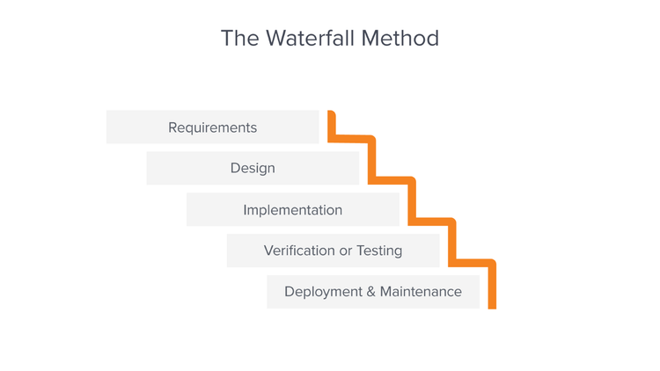

Figure 7: A visualisation of the waterfall SDM. (Lutkevich, B., 2019)

Once a phase is completed, it is deemed as completely finished, meaning there will be no regressing to previous phases during the cycle. (Hughey, D., 2009) This gives structure to the methodology as, by forcing teams to follow this regime, it ensures all areas of the project are completed to a high standard and all roadblocks are tackled immediately during their respective phases. (Ludidchart, 2017)

This professional state of structuration within the waterfall methodology has been recognised by firms within the real world, an example of such being the automotive manufacturer, Toyota. (Timeular, 2023)

In an interview with Toyota’s project general manager, Satoshi Ishii, he displayed a model of the company’s current development process using the waterfall methodology:

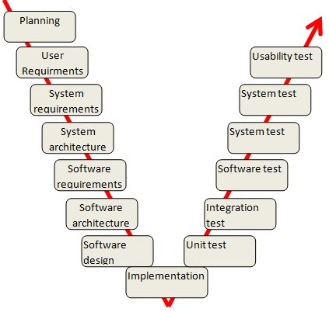

Figure 8: Toyota’s current development process. (Kniberg, H., 2010)

Figure 8 visualizes Toyota’s approach in design, with an emphasis on requirement identification and testing. As there is no repetition within the methodology, each phase must be thoroughly executed as to avoid any margin of error. The incorporation of multiple requirement and testing phases means more investigation can be put in place before and after the implementation of the product, reducing the overall margin of error.

However, though this methodology offers a well-structured work philosophy, it retains flaws. The process of a lack of repletion is flawed in of itself as testing is delayed, the implementation of test results cannot be deployed until the development phase is repeated within the methodology which can hinder a project in terms of time. (Paredes, R., 2023) Additionally, the methodology lacks any interaction with the client or user in terms of spontaneous feedback. Though there are user requirements, such requirements lack any proposals in regards to the current state of the project along with any changing opinions from the client, meaning a product may attain its assigned user requirements, it may not succeed in other aspects that need user feedback to prosper. (Singh, R., 2022)

The disadvantages surrounding the waterfall methodology are prevalent and have been a catalyst to influence firms into abandoning the method and pursue other methodologies. Toyota being one of these firms, with Satoshi Ishii stating that he was dissatisfied with how the design practices were affecting their means of production at Toyota. Such problems that were faced by Satoshi Ishii date back to the original concept of waterfall, with the very ideal of the methodology stating “The implementation described above is risky and invites failure.” When assessing the creation of the waterfall methodology. (Rovce, W., 1970)

With this in mind, Toyota would require an alternate methodology to accompany their transition, and the ideal choice for Satoshi was the agile methodology.

The agile methodology refers to a self-organizing approach to software development. (Collier, K.W., 2011) This means that, unlike waterfall, agile has an emphasis on repetitive development with constant researching and testing during “cycles.”

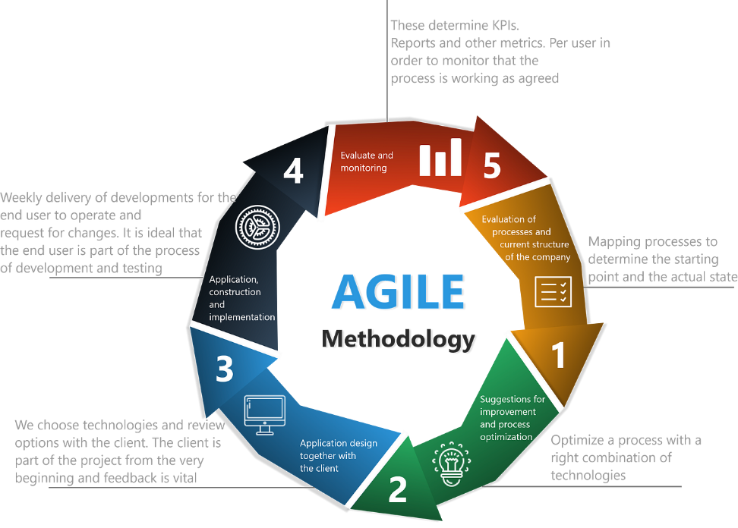

Figure 9: The Agile Methodology Lifecycle. (Abeythilake, U., 2022)

The agile methodology ditches the traditional aspects of waterfall by removing the restrictions regarding phase transitions. When a sprint is finalised within agile, its components can be revisited at a later time during another sprint.

Within 2023, at least 71% of all companies within the West used the agile methodology in their workflow, making it the most popular methodology bar none. (Beckman, J., 2023) This is due to the adaptability of the methodology and the spontaneous nature of projects. If errors occur within a project deployed within the waterfall methodology, these errors that arise outside of the allocated phase cannot be revisited until after each phase is completed. This process was considered flawed by software developers Robert C. Martin, author of the agile manifesto, and Fred Brookes, inventory and manager of IBM’s OS/360 stating that the methodology should be “thrown away” and was “flawed from the beginning” (Loenko, A., 2020)

These claims arise from the previously mentioned problems of “having one level of feedback means when following the process […] you end up with a list of requirements that nobody knows how it will cost to meet.” Quoted from Fred Brookes when discussing his experiences with the waterfall methodology. (Hanse, S., 2010)

Agile’s modern day approach to software development with an emphasis on testing and revisiting previous areas of work holds up in the grand scheme over waterfall as it leaves less margin of error when approaching deployment. With thorough testing and feedback analysis, agile projects can not only result in higher quality, but shorter timespans when performed at an industry standard level. (Lockhart, L., 2023)

That being said, it was an obvious decision to opt for the agile methodology when assessing which methodology to select. The outdated nature of waterfall’s innately flawed design left more to be desired than earned and agile’s constant attention to testing and feedback gathering while offering breathing room to aid in mistake correction and alterations of the project meant it offered quality of life features that were lacking in waterfall.

// <https://techreport.com/statistics/how-many-companies-use-agile/>

<https://link.springer.com/article/10.1007/s12599-010-0104-x>

<https://dive.medium.com/about-bob-martins-talk-the-future-of-programming-2016-f9408ee2e8ae>

<https://www.float.com/resources/agile-vs-waterfall/#:~:text=Speed%3A%20Waterfall%20projects%20tend%20to,development%20cycles%20used%20in%20agile>

# Software Development Lifecycle

After establishing that the project will be developed within an agile based methodology, sprints were established on a weekly schedule.

## Sprint #1 – Initial Design Principles *(6/11/2023)*

### Requirements

The second sprint of the project will begin with initial development and aim to achieve a full understanding of the design phases of the solution. Such objectives consist of:

* + - Creating an effective UI and UX design.
    - Applying user feedback to the initial designs.
    - Employing such feedback if deemed necessary

### Analysis

Within this sprint, the application selected to create valid UI and UX designs was Figma. Figma is a design tool that focuses on cross-compatibility and in-depth web and app UX and UI design. (Kopf, B., 2018)

With this tool, web development laws, such as the Fitt’s Law, are aimed to be achieved during the development process.

### Implementation

The use of Figma allowed creation to be made swiftly and effectively without issue.

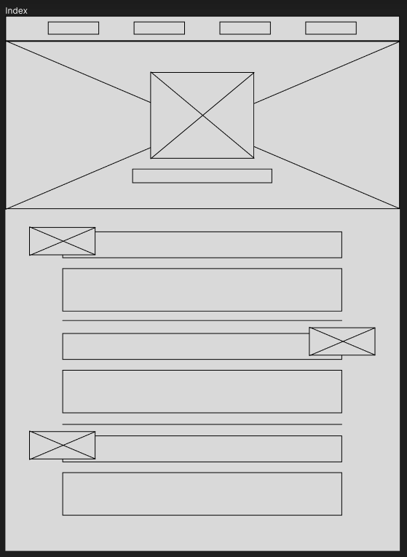

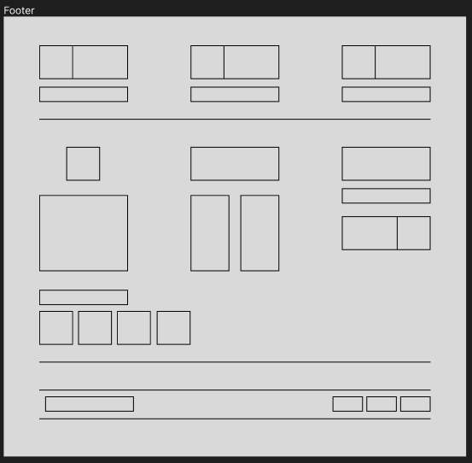

Figure 10: UX Design of the project proposal <https://www.figma.com/file/voITJIsPWh96a8jgM2DXTN/Dissertation-UX?type=design&node-id=0%3A1&mode=design&t=3PaPEfDe0Tb1zHgh-1>

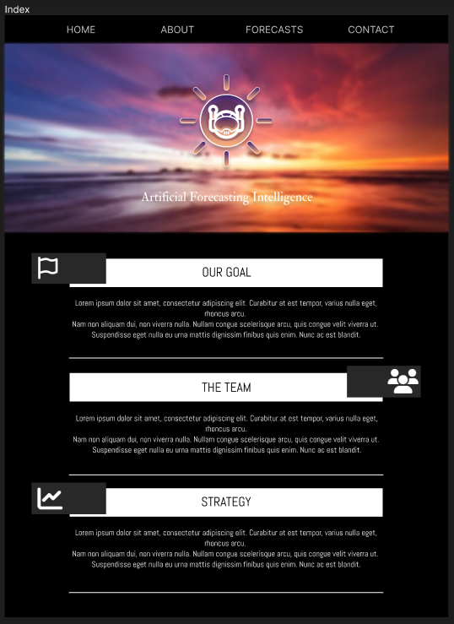

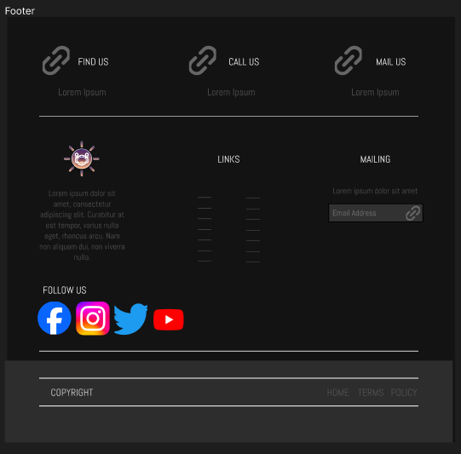

Figure 11: UI Design of the project proposal <https://www.figma.com/file/yLwtwn2OCNRHAeQifUxPYz/Dissertation-UI?type=design&node-id=0%3A1&mode=design&t=PI1lUEsD00zDfiNC-1>

Figures 10 and 11 show the development of an index page for the solution, highlighting elements of web design laws. I.e., the incorporation of Fitt’s Law gives the user immediate options of the navigation bar along with the brand identity.

After considerable anonymous user feedback, areas of improvement were accessibility. The dark nature of the webpage meant that information could be harder to see when outside due to screen reflection.

With this in mind, areas of the design are modified to adjust to the feedback:

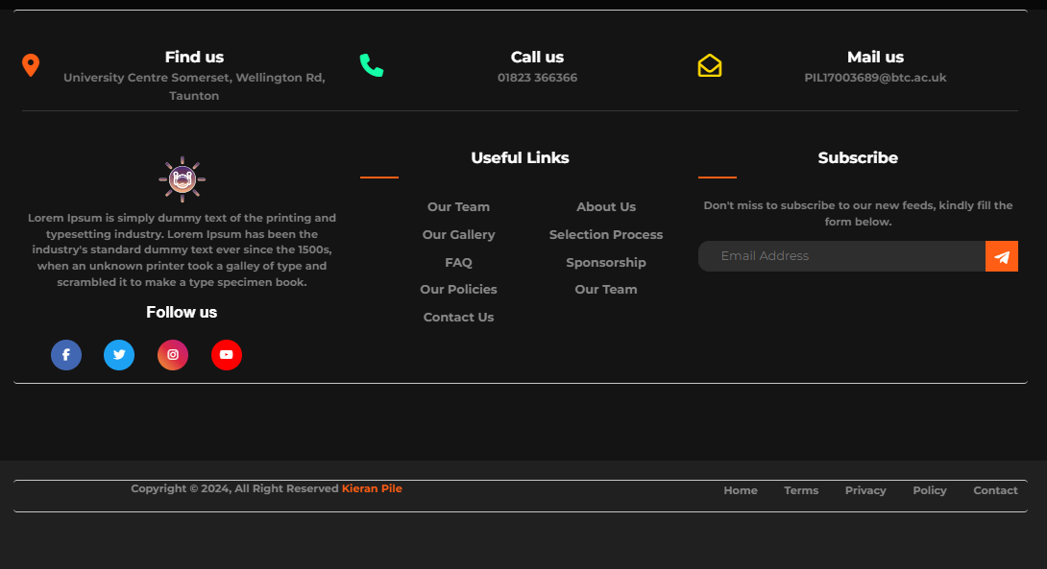

Figure 12: The Footer of the UX Design becoming more vibrant as a response to user feedback.

In regards to figure 12, important information is highlighted, along with symbols being changed with brighter colours to better aid in colour correction.

### Summary

In conclusion to the sprint, UI and UX has been implemented successfully and adjusted to user feedback. The selected tools have made creation simple whilst design philosophies have helped engage in user satisfaction. Additional tests and queries are seen within the test table in the Appendix.

## Sprint #2 – Webpage Development *(4/12/2023)*

### Requirements

After creating a successful UI design in accordance to the requirements, the design can be deployed onto a web-based solution.

* + - Create a project to begin development.
    - Replicate the design on a web page.

### Analysis

The translation of the UI design into a web page will require the incorporation of multiple programming languages. The two major benefactors being PHP (HTML) and CSS.

These two languages provide more than enough features regarding the front-end development of the web page such as the styling of backgrounds, fonts and text colours along with the processing of animated images.

### Implementation

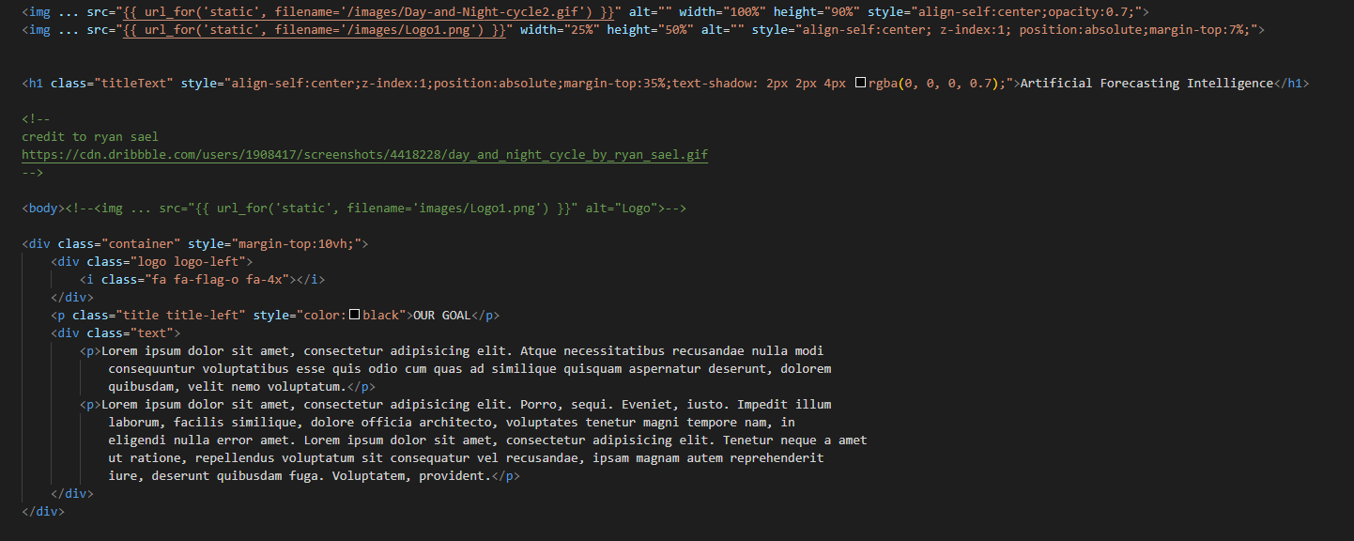  
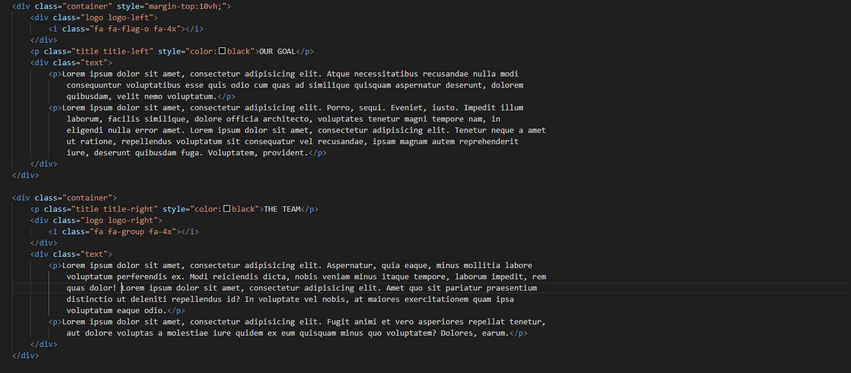

Figure 13: The front-end code for the index of the solution. More styling can be seen within the Appendix.

After this coding and styling is complete, the webpage will look like:

  
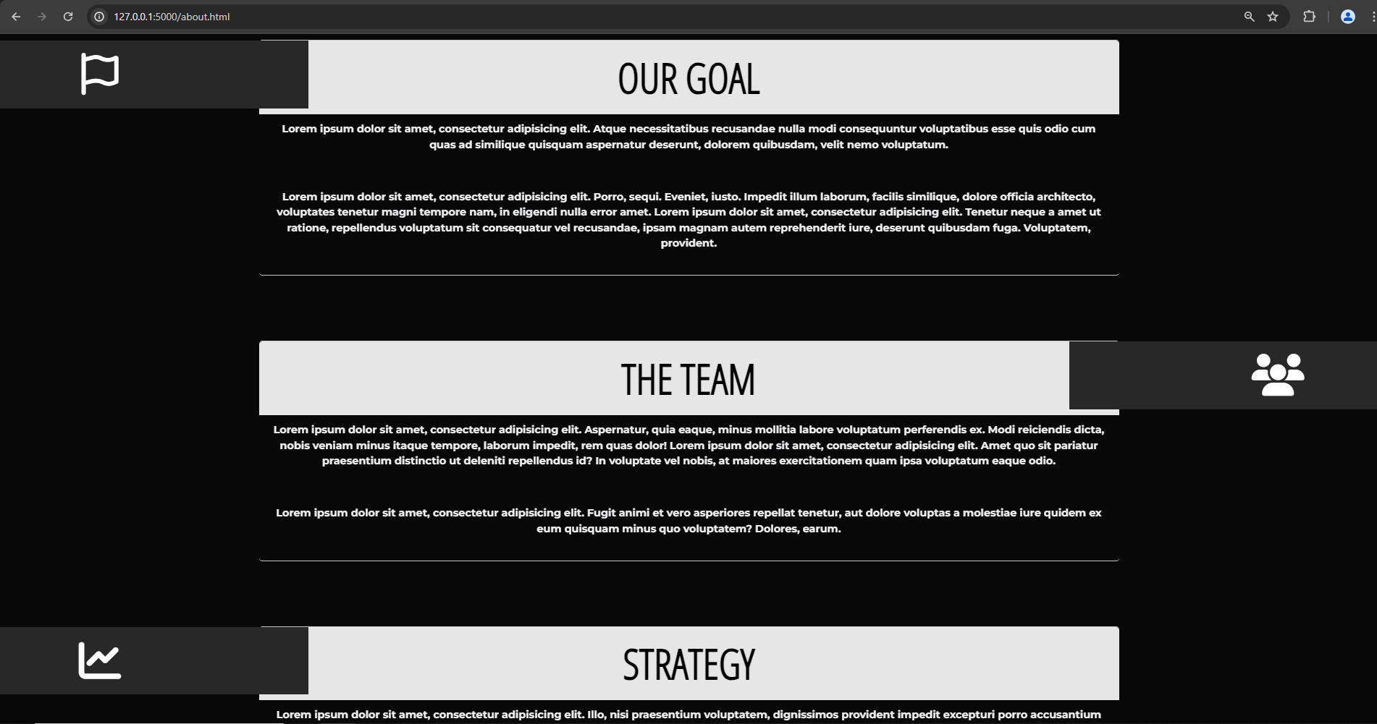

Figure 14: The end result for the index styling

After the visualisation was deployed, anonymous user feedback was gathered regarding the design. Now that the UI was implemented, it could be viewed as a web-based solution, meaning a broader range of stylistic options were available. An example of this, collected from user feedback, was the addition of animation. The navbar was deemed ‘boring’ and a suggestion was to add styling when the elements were either clicked or hovered.



Figure 15: The navbar after implementing on hover values

After adding more visual stimuli to the navbar, the users were satisfied with how the navbar was styled.

### Summary

The sprint had a primary aim on presentation before development starts. After creating a satisfactory UI and UX design within Sprint 1, the front end of the web-based solution was able to follow the design and be finalised within Sprint 2.

## Sprint #3 – Development of a Flask Solution *(8/1/2024)*

### Requirements

Flask is a python library that can be used to deploy an AI model onto a web page. This is done through the use of rendering webpages through the application and running the application in tandem with the AI model.

To establish this, the requirements are:

* + - Creating a flask file.
    - Converting incompatible files.

### Analysis

An immediate issue when developing a flask program is the compatibility with PHP. Flask will only process HTML files, thus the pre-existing PHP files will have to be changed, meaning the code within them will need to change.

### Implementation

A major issue with changing from PHP to HTML is including other pages, such as the navbar and footer. Without this, information cannot be displayed and redirects cannot occur. Fortunately, there are ways around this within HTML.

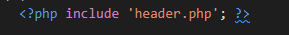  
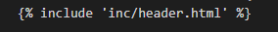

Figure 16: Exemplar of changing components to be compatible with flask

Figure 16 shows an adaptation of such an occurrence, by slightly adjusting the code, the same activity can be achieved within HTML as it could be in PHP.

After such configurations have been made and tested, the flask file can be programmed.

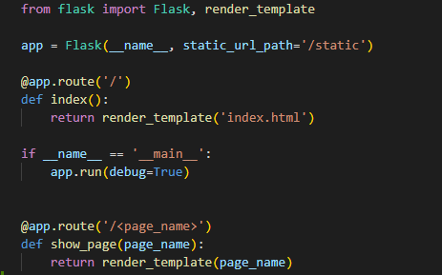

Figure 17: The flask file is made

This flask file will always render the index page initially when opened, ensuring navigation is always the same. From there, each page is rendered based on its page name, i.e.,

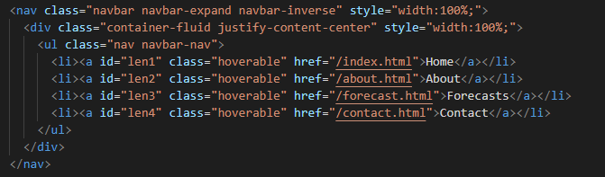

Figure 18: A navbar that uses href to call pages

If the navbar calls the references “about.html” the flask file will find the route of that page name and show the corresponding page as long as it exists.

### Summary

The incorporation of a flask file for AI deployment is vital. This program will allow full compatibility with displaying the model along with rendering the pre-existing pages properly.

## Sprint #4 – Data Cleaning and Analysis *(5/2/2024)*

### Requirements

The act of data cleaning is vital to ensuring a machine learning model is accurate. By removing potential inaccuracies and properly preparing the data, results will become more accurate.

* + - Performing Data Understanding.
    - Carrying out Data Cleaning and Analysis.
    - Visualising data to ensure cleaning has been resolved.

### Analysis

Data cleaning is a long process but the most important part of AI modelling as, without accurate data, there will be no accurate results. By using Jupyter Notebook, data cleaning can be laid out in a user-friendly format and each instance of data cleaning can be carried out individually.

### Implementation

To begin with, libraries must be imported in order for data cleaning and AI modelling tools to be used.

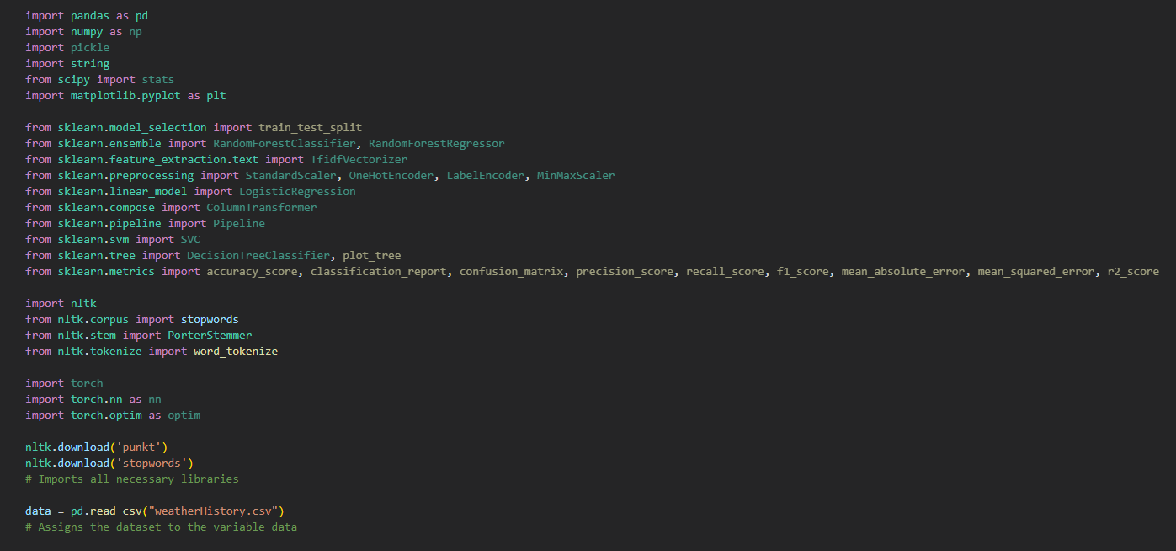

Figure 19: The importing of Python libraries

These libraries can range from data analysis and understanding tools in Pandas to data visualisation and mathematical tools in Matplotlib and NumPy respectively.

#### Data Understanding

With the libraries imported, the data can be viewed by the user to identify any underlying errors with it.

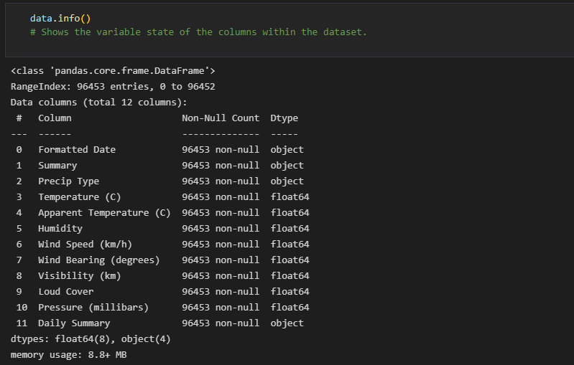

Figure 20: An example of data understanding using .info()

Figure 20 shows an example of data understanding by showing the variable state of the columns of the dataset. Instances of strings will be defined as an object whilst integers are float64. Additional data understanding techniques can be used within this step of the CRISP-DM methodology such as .describe() to view information regarding the columns of the dataset as seen in Figure 21.

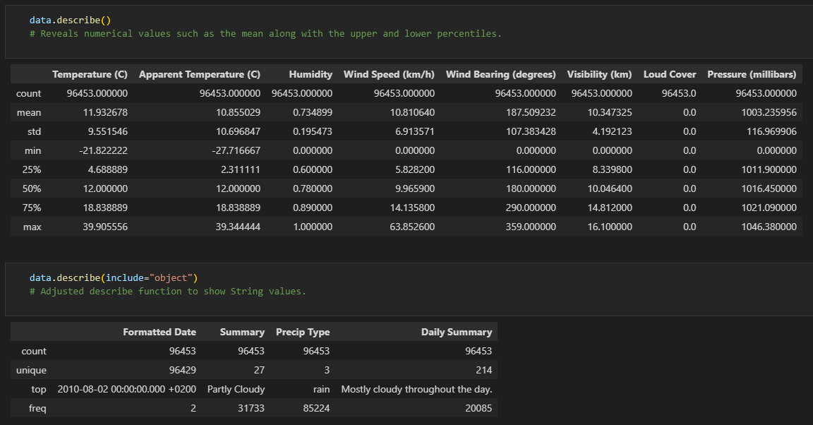

Figure 21: Using .describe() with and without including objects to see information regarding the dataset

#### Data Cleaning

Although the data has been analysed by a human, there are instances of error that may not be detectable by average people, thus data cleaning is incorporated to fix any potential errors that may be in place.

Multiple instances of data cleaning should be applied to a dataset before using it. This will include filling in null data, replacing invalid data, removing repetitive data, and performing data visualisation to ensure data is properly cleaned.

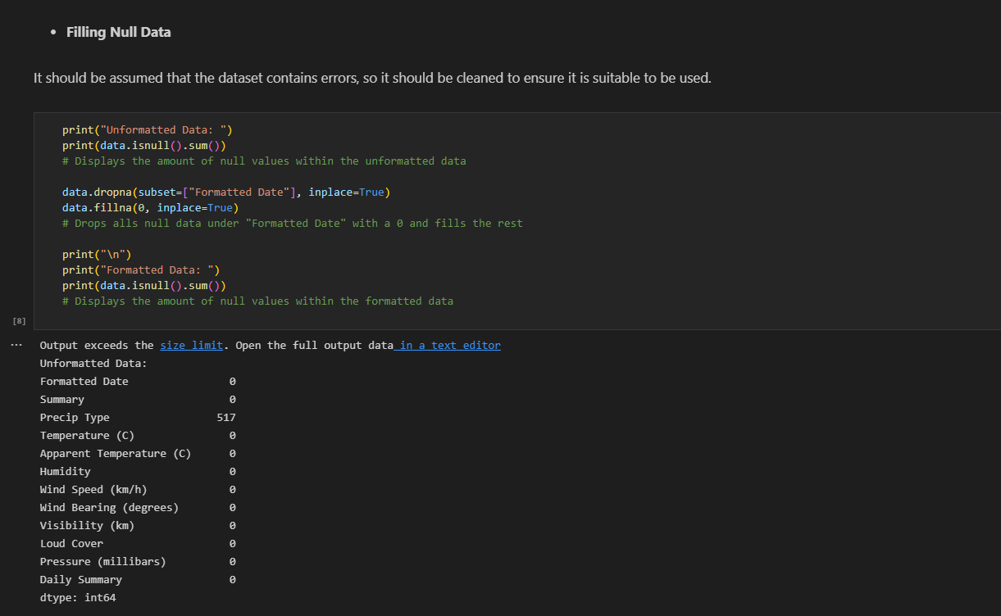

Figure 22: Finding any null data and replacing it.

Figure 22 demonstrates how null data is handled. Data is either filled or dropped depending on its importance. Important data cannot be filled as it would skew with the end result, thus must be dropped, whilst unimportant data can be filled.

Although the data has been properly managed, this data may be found to be repetitive. This means that one instance of data may have been entered multiple times by accident. This repetition may tamper with data visualisation, thus should be removed.

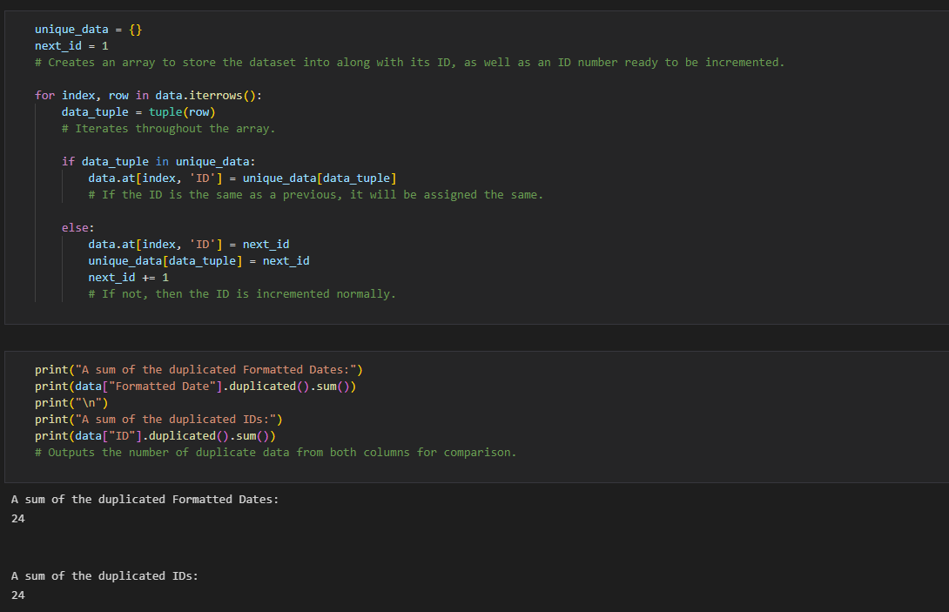

Figure 23: Assigning unique identifiers to the data within the dataset

Figure 23 shows the process of using unique IDs. These IDs will aid in identifying what data within the dataset is unique and how many duplicates are spotted. After doing so, it can be determined that there are 24 repeated instances of data. These repetitions must be removed.

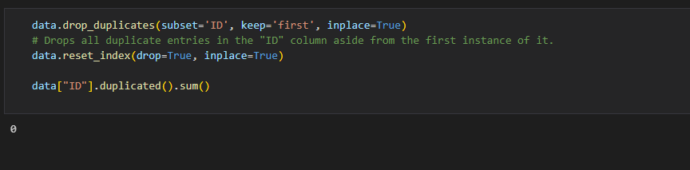

Figure 24: The dropping of duplicate data

After assigning unique identifiers, the duplicated data can be dropped from the dataset, as seen in Figure 24. This aids in the cleaning of the dataset and ensures no duplicates remain.

From there, data cleaning techniques will focus more on enhancing the data, ready to be used by the machine learning model, as seen in Figure 25.

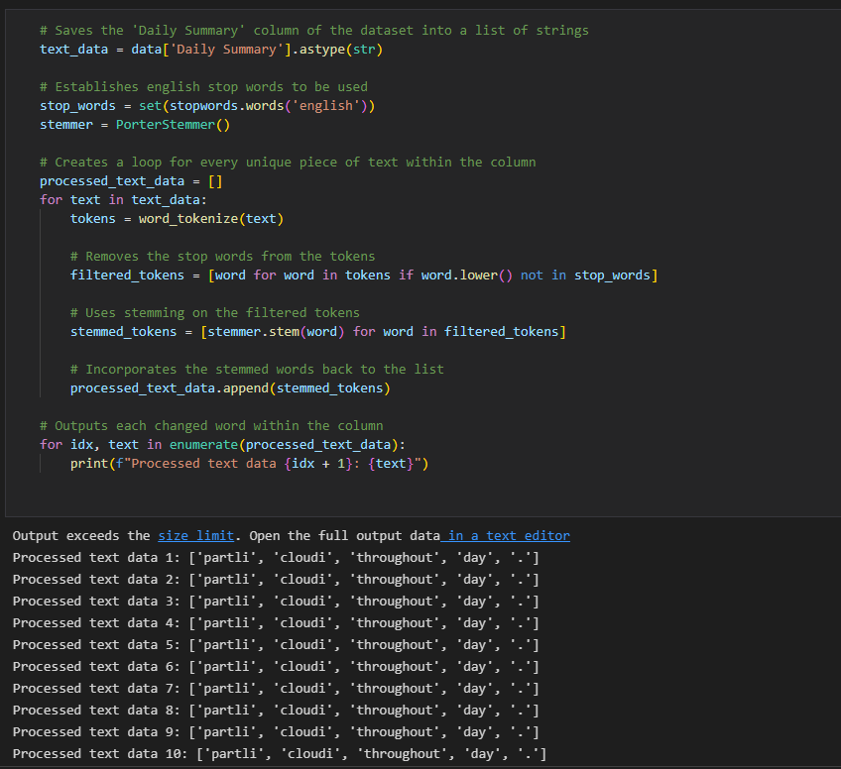

Figure 25: Stop Word Removal being used on the dataset

Figure 25 is an example of Stop Word Removal, where unimportant suffixes and prefixes are removed from data. Words such as ‘the’ cannot be processed by a machine learning model, thus have no relevance aside from consuming load times. By removing these words, the processing of the data is made faster.

Additional types of data cleaning for ML models are Tokenization and Vectorization.

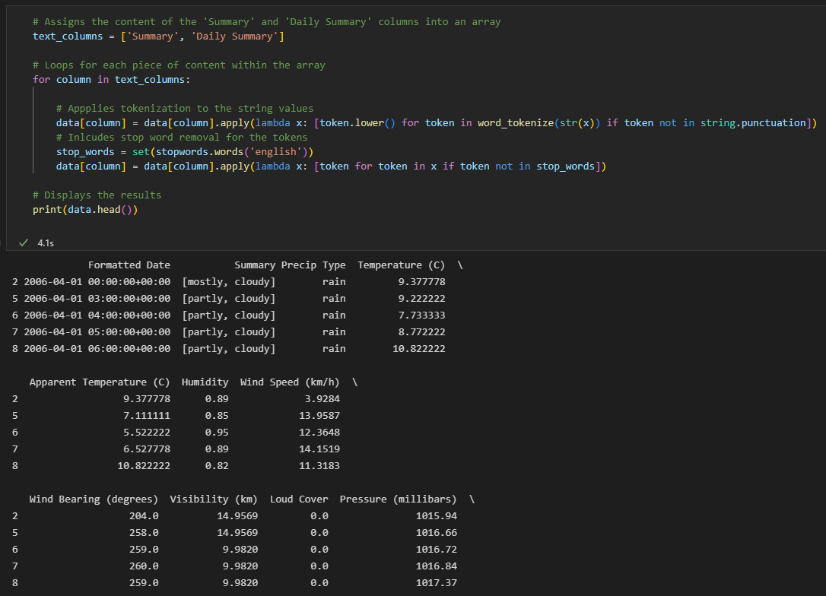

Figure 26: Applying Tokenization to the dataset

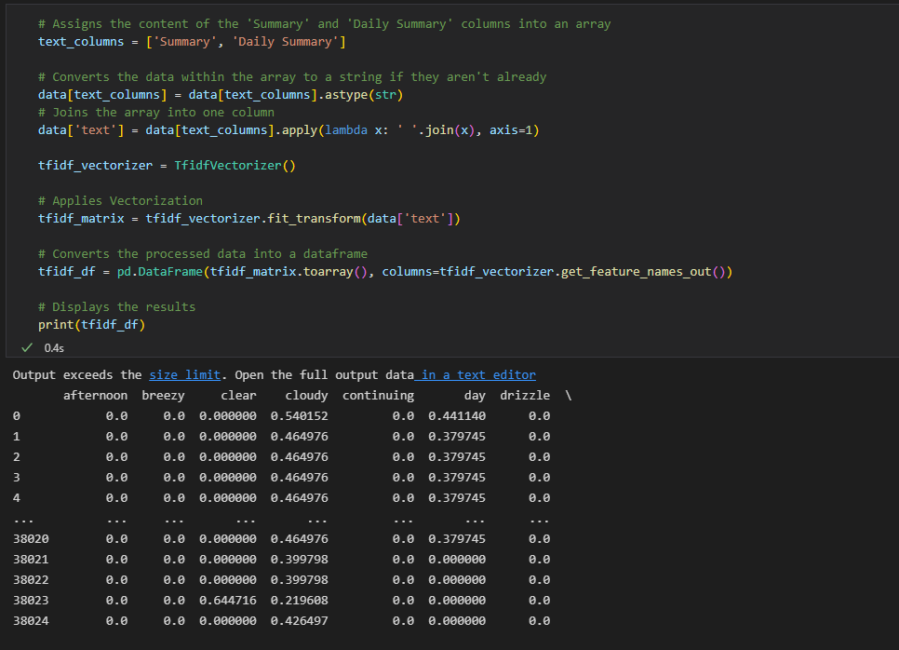

Figure 27: Applying Vectorization to the dataset

These two instances of data cleaning allow the ML model to understand the data easier, like a translator.

#### Data Visualising

Data Visualisation allows us as humans to perceive the effectiveness of data cleaning.

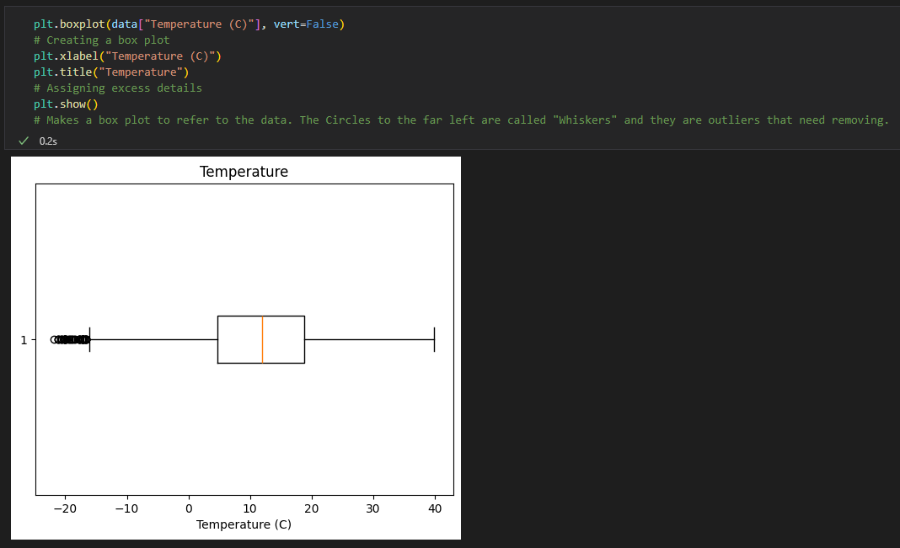

Figure 28: An improper box plot from the cleaned data

Figure 28 shows the visualisation of data from the cleaned data. As seen, the boxplot is relatively proper, being formed without error. However, there still remains outliers, being data that does not fit the theme of the dataset. These outliers can be removed using interquartile ranges.

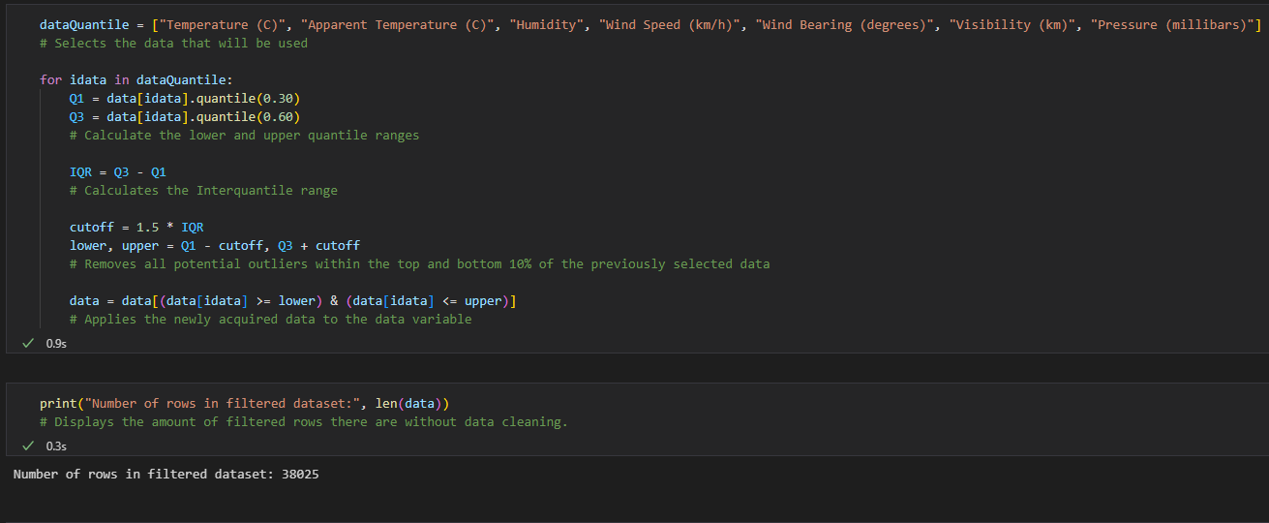  
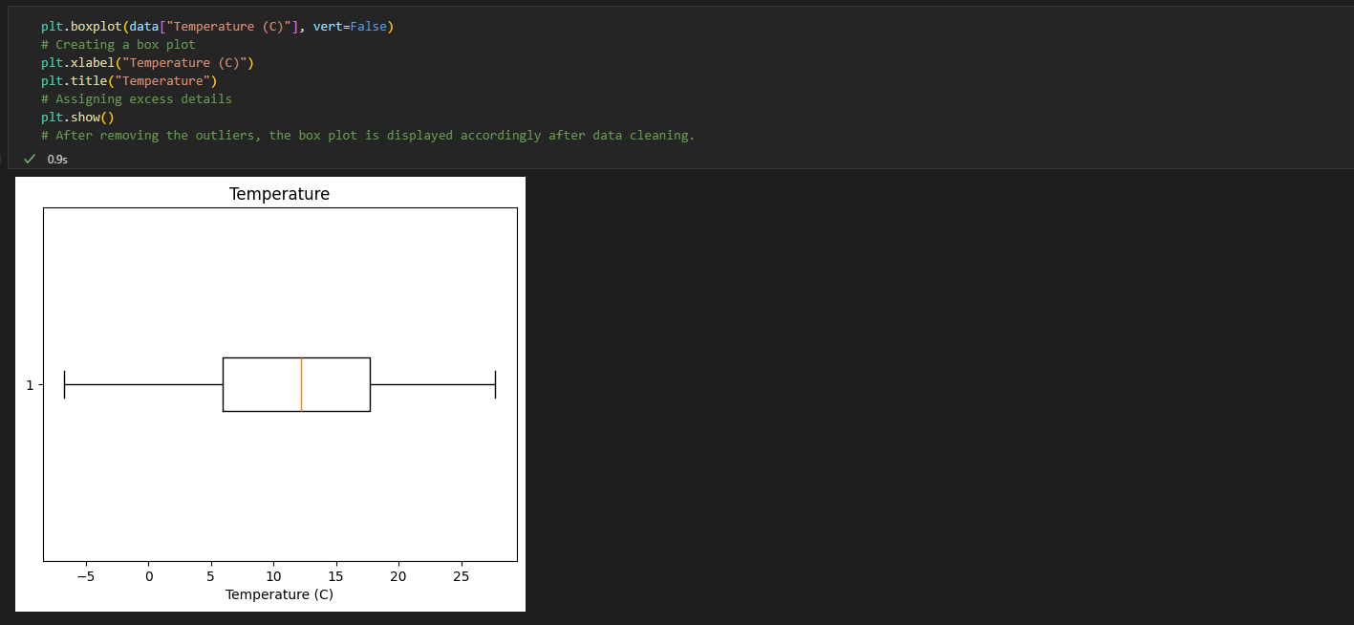

Figure 29: Using interquartile ranges to remove the outliers of the boxplot

This is achieved through the process in Figure 29. By finding the upper and lower quartile of the data and removing them, the interquartile range can be found and displayed, making a perfect boxplot.

### Summary

Data cleaning remains the longest process of AI modelling, but is the most important. Without it, results will be completely different and skewed readings are less than ideal. The vigorous cleaning of the dataset allows the model to be as accurate as possible.

## Sprint #5 – AI Model Development and Training *(4/3/2024)*

### Requirements

Creating an artificial intelligence can be done through multiple different mediums. These include, but are not limited to, random forest and linear regression. To assess which type of model would be the most effective, each will be constructed and compared.

* + - Model multiple ML models.
    - Analyse performance.
    - Conclude which model to deploy.

### Analysis

AI models use metrics such as accuracy, F1 and R² scores to assess their effectiveness. The F1 score consists of the model performing predictions and summarising its own results to the dataset’s actual results. The R² score refers to the variation within the model’s prediction compared to the overall variation of the dataset. A low R² score indicates that the model has used a small variation in data to create its results.

### Implementation

#### Random Forest

To begin with, the random forest model is created. This model uses decision trees to create correlations between hypothesis of the data. These trees, that may be noncontextually adjacent perform more accurate results when formed as a group.

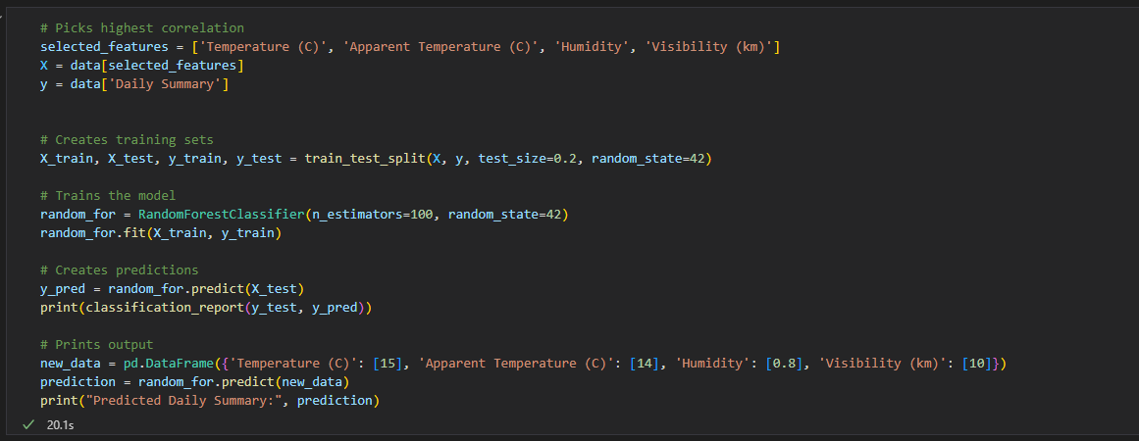  
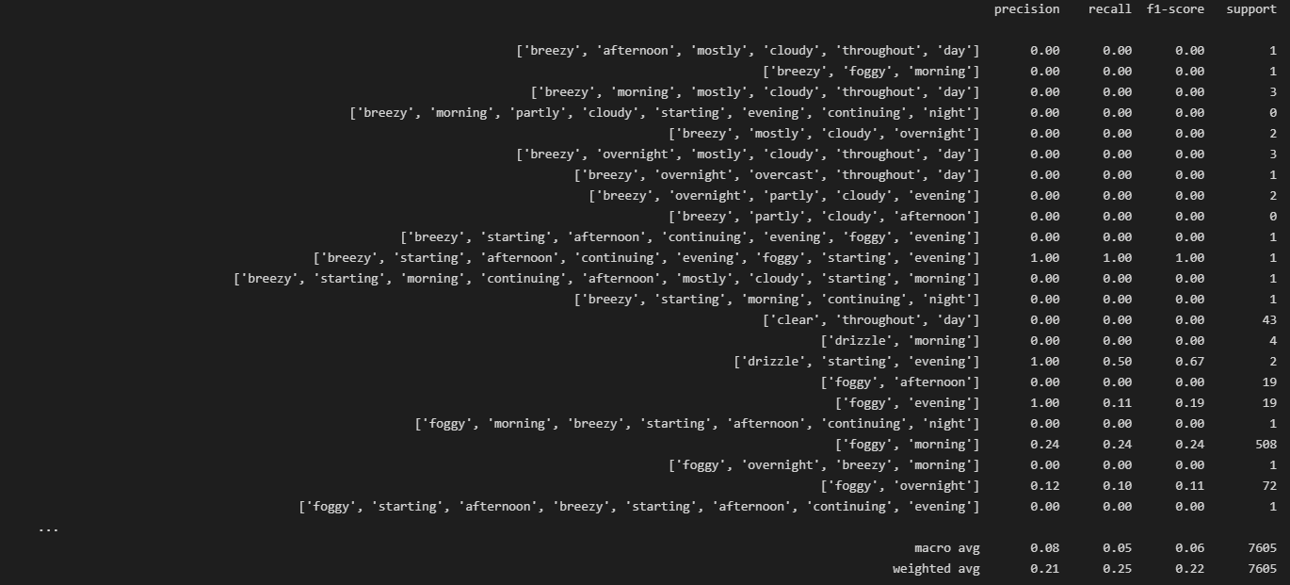

Figure 29: A Random Forest model displaying its predictions and accuracy

#### Linear Regression

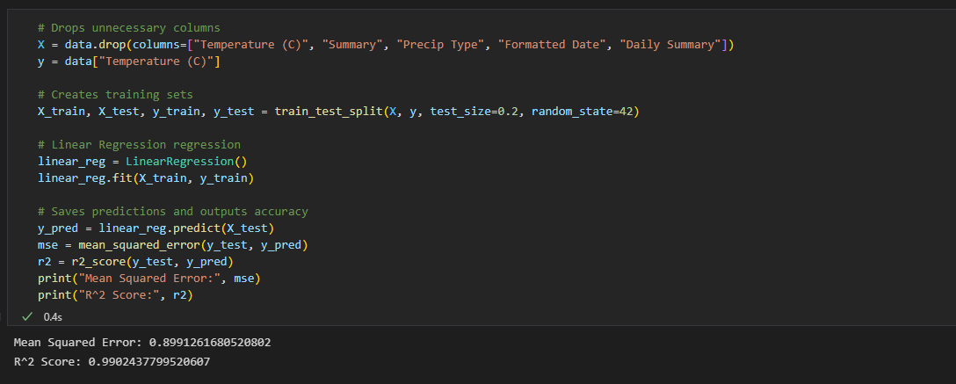

Figure 30: A Linear Regression model showing its mean squared error and R² score.

#### Neural Network

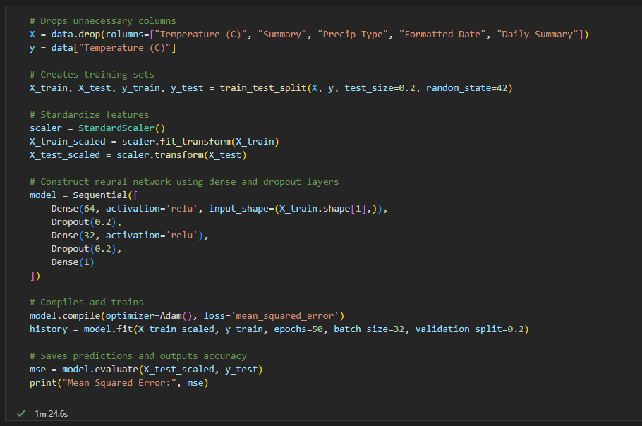  
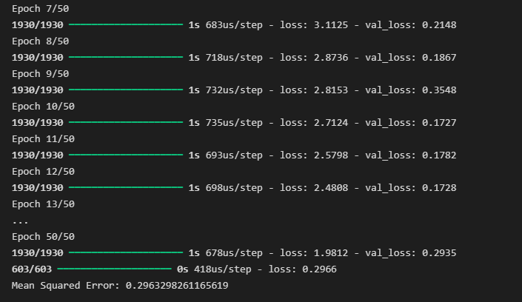

Figure 31: A Neural Network model that returns its mean squared error.

A neural network will consist of epochs and batch sizes as its main variables. A batch size revolves around splitting an area of dataset into a batch for each epoch to process. I.e., the batch size for this neural network is 32 over 50 epochs. This can be simplified as the model performing 50 iterations of training on the 32 instances of data.

With this information, more can be found out regarding the model, such as the total epoch amount. This recording can be used for additional alterations regarding the efficiency of the model.

The total sample size is calculated using this equation:

$$Epoch Amount*(\frac{Total Number of Samples}{Batch Size})$$

The information provided is not enough to perform the calculation as the number of samples is missing. One could estimate the amount by manually counting entries within the dataset but, with greater sized dataset, this would become too time consuming. Additionally, manual calculations will result in the uncleaned data being considered into the calculation, thus a script can be executed to calculate the sample size automatically.

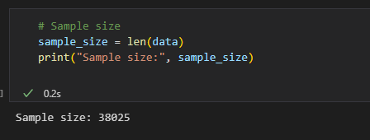

Figure 32: Finding the Sample Size of the dataset.

With this newly acquired data, the total sample size is found:

$$50 Epochs*\left(\frac{38,025 Samples}{25 Batch Size}\right)=Samples Size of 76,050$$

This information can be useful in the assessment of efficiency and optimization. By altering the variables in the number of epochs and batch sizes to correspond more with the sample size, the mean squared error can be optimized to become more accurate.

#### Accuracy Assessment

Now that there are three baseline models, one must be chosen to be deployed. This decision will be dictated by the accuracy of the models. In this case, the mean squared error will be used to determine the most accurate model.

The mean squared error measures how close the model’s predictions are to the actual results. This makes it a good method to analyse accuracy as a good criterion for the models will be to be as close to real data as possible.

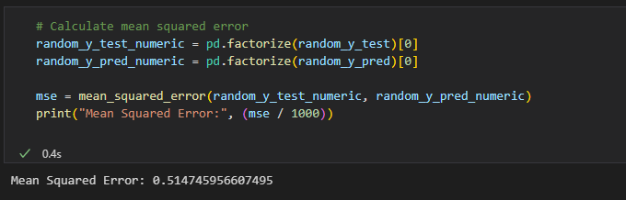

Figure 33: Finding the mean squared error for the random forest model

By outputting all instances of the mean squared error, the final readings are as followed:

|  |  |
| --- | --- |
| **Model** **Name** | **Mean** **Squared** **Error** |
| Random Forest | 51% |
| Linear Regression | 89% |
| Neural Network | 29% |

With this in mind, the accuracy of the models is based on how much spread the predicted data is from the actual data. With the random forest and linear regression models, they both exceed 50% variation from the actual results, whilst the neural network has only a 29% deviation, making it the most accurate.

That being said, the neural network model is deemed the most fitting for the solution.

## Sprint #6 – Deployment *(15/4/2024)*

### Requirements

After establishing a choice on an AI model, it is deployed onto a web-based solution to be able to view results.

* + - Create a Flask file to deploy the AI on.
    - Code sufficient back-end to display the AI’s predictions.
    - Add additional compatibility with user inputs.

### Analysis

Flask offers immense support for the AI in a form of loading the saved model and displaying it onto the webpage.

### Implementation

#### Saving the Model

To be able to deploy the model, it must be saved first.

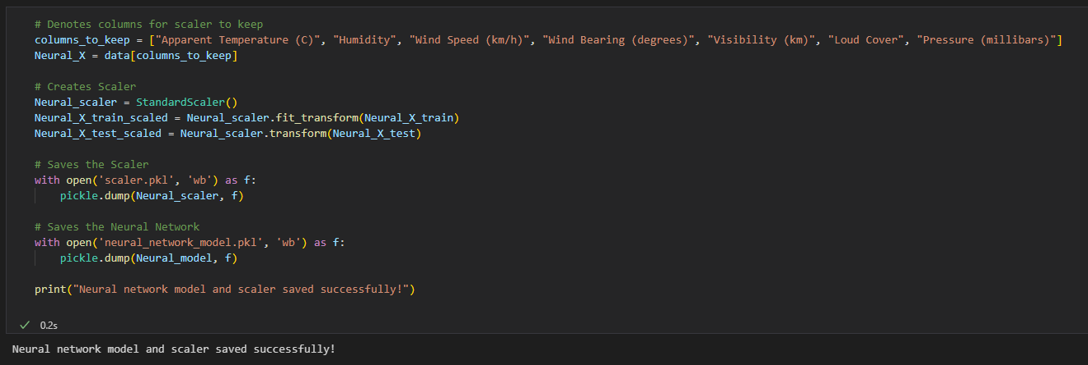  
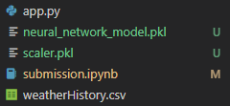

Figure 33: Saving a scaler and neural network to be deployed

Now that the model is saved successfully, it can be deployed onto the web page.

#### Flask Back-End

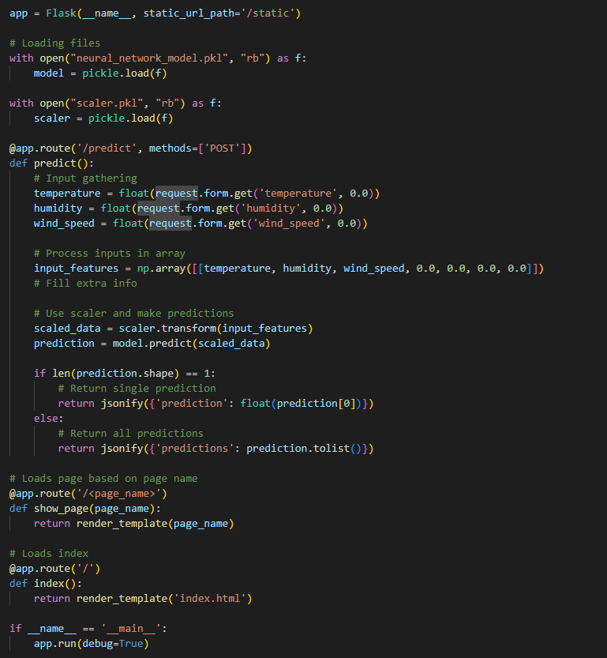

Figure 34: Flask back end for processing user input

Within the flask file, user inputs are processed using form requests from the predict function. There, the inputs are stored into an array and processed, making a prediction using the scaler and neural network.

#### HTML Front-End

Within the front end, there are two key features that need implementing; a form and a script to process the form.

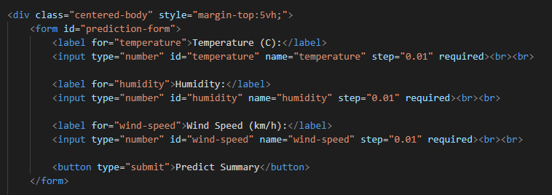

Figure 35: A standard user input form

The form is simple, providing an area for the user to input their data.

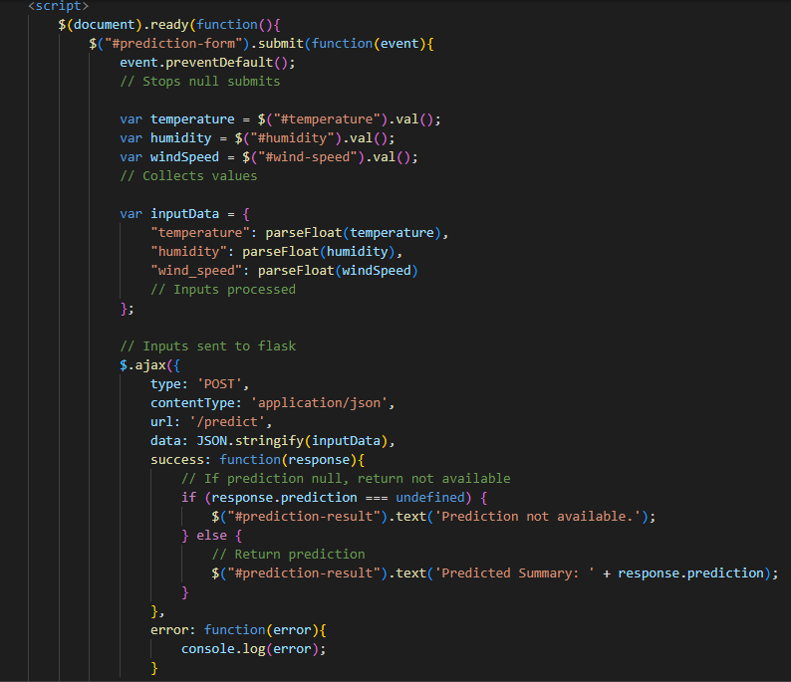

Figure 36: JavaScript to perform form submission

Once a user inputs their data, the prediction will be made and displayed.

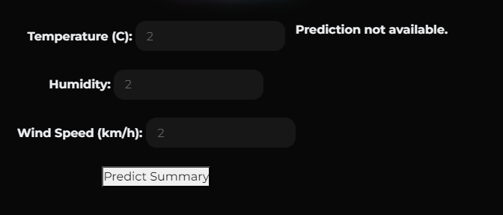

Figure 37: Demonstration of a prediction failing to generate with the user input

Though, in figure 37, the prediction allegedly fails, an epoch is still made on the back-end, meaning that the neural network is still forming predictions despite it not rendering.

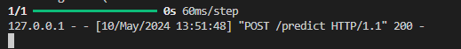

Figure 38: An epoch is created upon user data submission

## Sprint #7 – User feedback & API handling *(6/5/2024)*

### Requirements

With the model working successfully, user feedback can be collected to build upon any missing features that potential clients would like to see.

* + - Gather user feedback.
    - Assess the ability to carry through with feedback.
    - Process and develop upon feedback.
    - Submit end product.

### Analysis

To collect user feedback, a form can be given to those who use the solution and the responses can be recorded for analytical purposes.

### Implementation

User feedback will be collected and stored using Google Forms and Google Sheets respectively. These tools offer a fully customisable experience with collecting real time user feedback.

This form is available: <https://forms.gle/evidCDrySGtP9NqW9>   
and spreadsheet: <https://docs.google.com/spreadsheets/d/10vC--QacKGEgTO9zaPN0UrTP2LTyjZVTl4ImYZPGXBY/edit?usp=sharing>

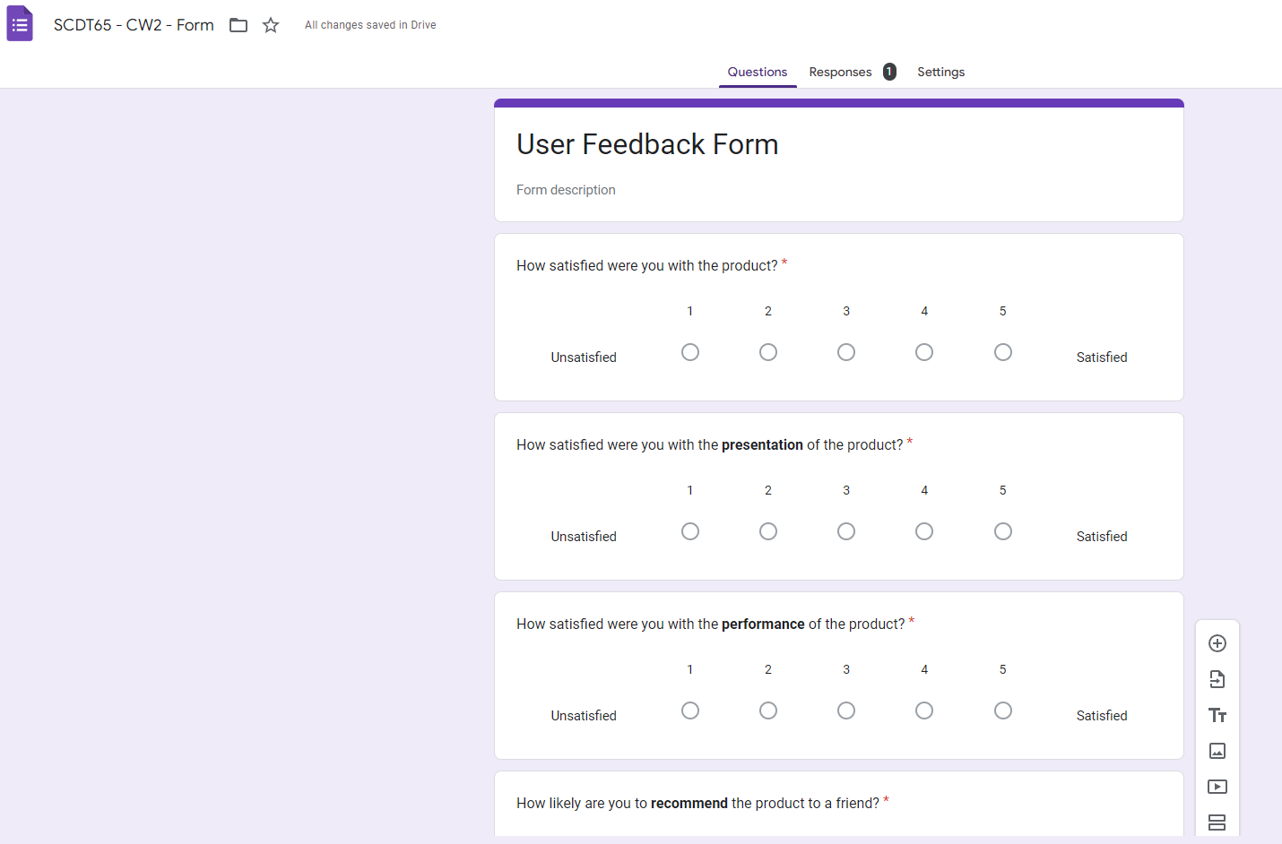

Figure 39: Creating a Google Form with questions ready for user feedback

Forms can be linked to Sheets via the inbuilt GUI that allows for easy data transmissions. For example, a test run of the form was carried out to ensure it worked:

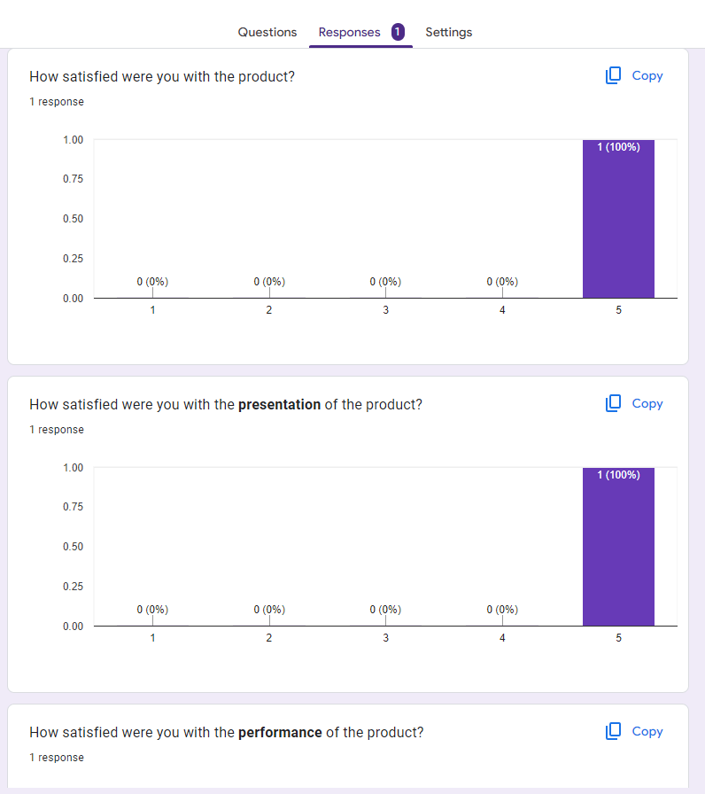

Figure 40: The results of a test of the Google Form

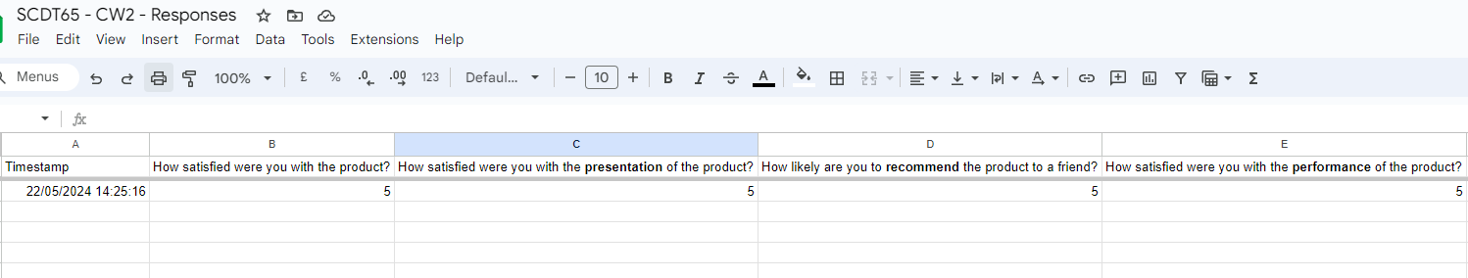

Figure 41: A collection of the test result via Google Sheets

By collecting user data this way, it can be analyses and visualised through Google Sheets. For example, conditional formatting can be applied to the document to more easily demonstrate the results of the form:

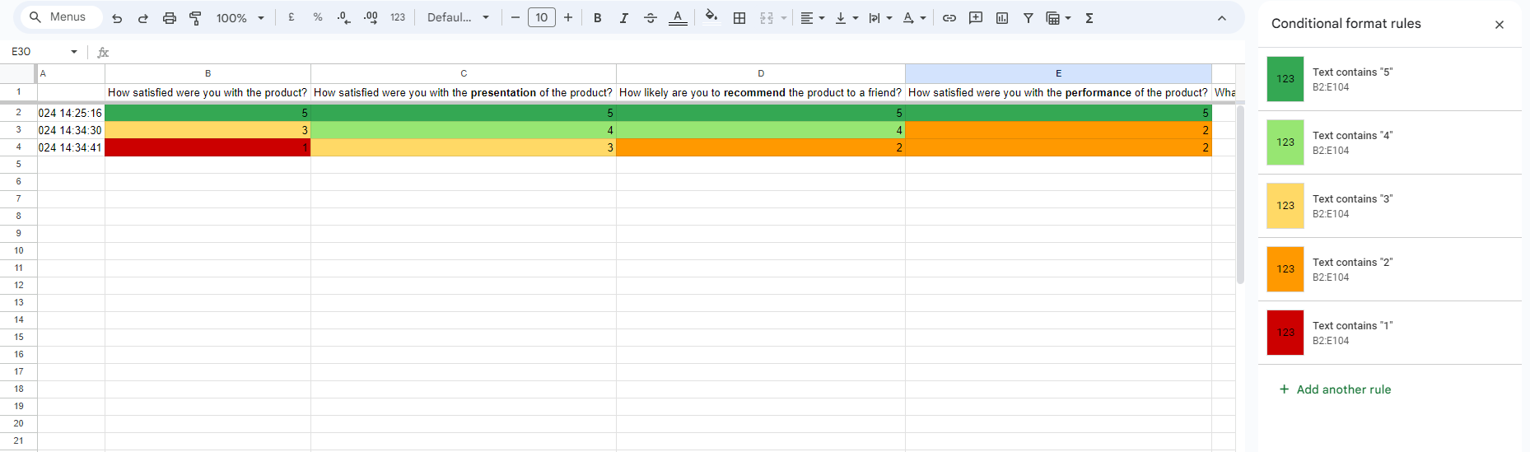

Figure 41: Applying conditional formatting to better visualise results

This form of data collection allows for easily distributable reports regarding the performance of the solution along with gathering additional user feedback for future testing.

To actually obtain user feedback, said user needs to be able to have the form:

  
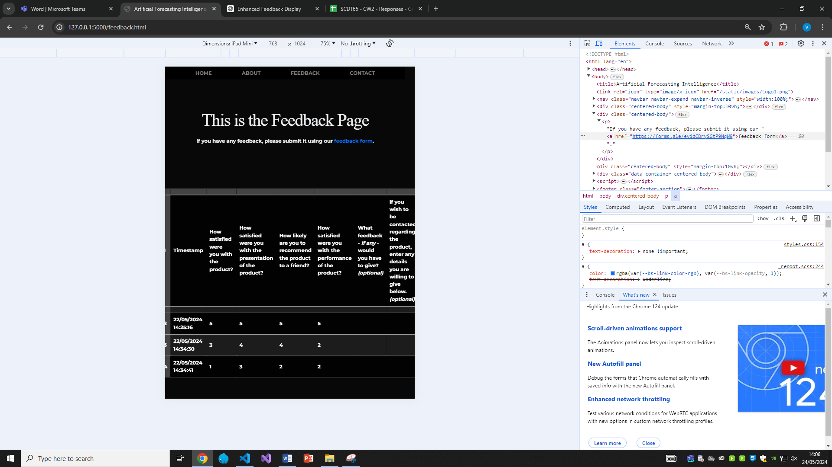

Figure 42: Giving the user a way to give user feedback via the webpage

This link will send the user directly to the form when clicked for them to fill it out. Additionally, the use of the Google Sheets API can allow the results to be displayed onto the webpage directly.

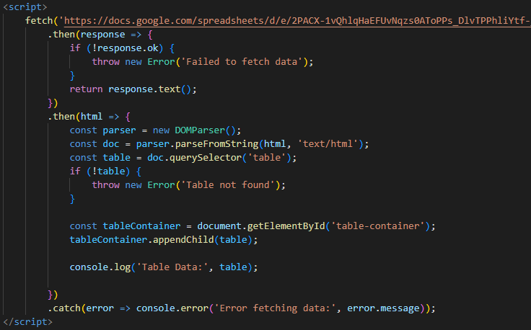

Figure 43: Incorporation of Google Sheet’s API to show the Sheet data on the webpage

By fetching the published sheet, its data can be returned onto a table within the webpage to be displayed. By adding styling to the table to fit the theme of the page, it returns the results of all the users’ feedback.

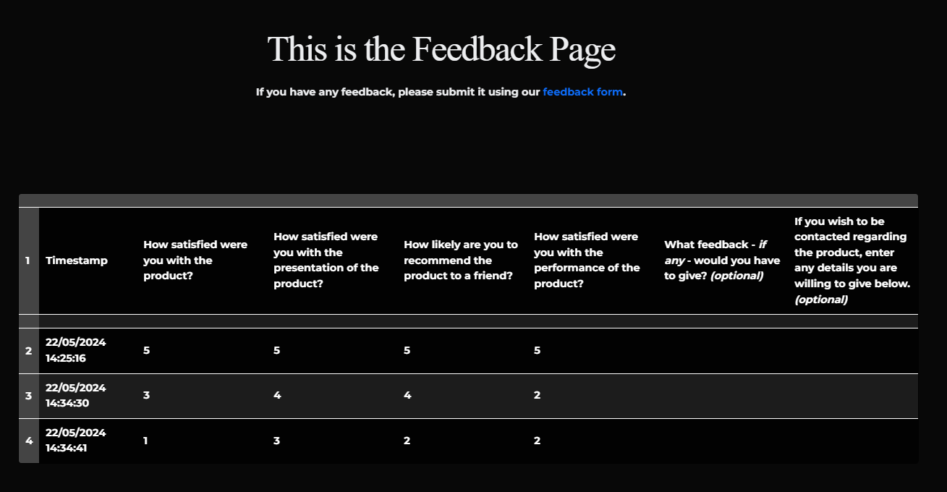

Figure 44: The final results of implementing user feedback to the page

# Project Evaluations

## Testing

Throughout each sprint of the project, multiple forms of testing were measured to ensure optimal results of the solution. These procedures included:

### Unit Testing

Unit testing consists of selecting and focusing on individual elements of the solution to test its usability. This is typically found in areas of the code that can be executed in both the whole program and in isolation. (Bakharev, N., 2023)

The medium of a Jupyter Notebook for the project meant that unit testing was made easier to execute as each layer of code could be run freely. This consisted of each phase of CRISP-DM being allocated to different layers and the code within being executed freely. By using Jupyter Notebook; data cleaning, modelling and deployment were all able to be tested and executed uniquely, ensuring that unit testing was always present within every sprint.

### Integration Testing

Integration testing focuses on the wider application over unit testing’s deeper delve into certain elements. By testing the application in full, integration testing is used to facilitate the need for change in regards to compatibility within an application’s back-end and front-end communication to ensure everything works to a standard. (Schmitt, J., 2024)

Within the project, integration testing was used to test the compatibility of the AI model to the Flask web to ensure it could be deployed successfully. By incorporating integration testing within the solution, it allowed the program to be simulated as if ran by a user, offering a user’s perspective and guaranteeing all features were available to them.

Integration testing was emphasised within the latter sprints after CRISP-DM was employed. By creating a back-end component, the use of integration testing meant that all forms of communication between front and back end elements were suited for solution.

### Acceptance Testing

Acceptance testing is the procedure of verifying the system meets the end user’s approval. (Gillis, A., 2021) Within the project, user acceptance testing was chosen over quality assurance acceptance testing. This was processed through the use of a beta phase that allowed external users to experiment with the application and provide user feedback anonymously. (Elazar, E., 2018)

By performing this stage of testing, the application was able to be used within a standard environment without being firstly deployed, allowing for any additional modifications in regards to user feedback before deploying fully.

## Overview

The project was able to achieve the final criteria within the allotted time using the respective methodology. Each objective was met with either a successful, or attempted, conclusion which allowed the project to be completed within the allotted timeframe.

By incorporating the agile methodology, each criterium was able to be tackled within a controlled environment and allowed for a more focus approach to each area of the project over other methodologies. Additionally, extensive user feedback was collected throughout the phases of the project, thus this methodology allowed for more lenient rehearsals of each area within the solution and, unlike an exemplar mythology such as waterfall, meant that previously finalised areas were able to be revisited using said feedback.

Furthermore, the incorporation of different test cases was made easier through agile due to the nature of each sprint consisting of a testing phase, meaning that each component of the program was able to be fully tested to ensure functionality.

However, the project lacked an industry standard level of deployment through a web and back-end hosting service, thus the project was limited to whomever had accessibility towards the project. This margin of error was combatted by uploading the solution to GitHub. This meant that the project was available to those who seek it out, ultimately lowering the wider reach of deployment, but also allowing for other GitHub users to add upon the project, making the project open source.

## Legal, Social, Ethical, Economic and Professional Impact

The project remains open-sourced, meaning modifications and deployment by others users can be acquired through the respective cloud repository services. Although the project has no economic value, all provided artwork remains credited to the original creators within the solution.

The project is considered undeployed and is not covered under any copyright related queries, falling under the General Public License, giving users the freedom to run, study, share and modify the software. (Stallman, R., 2002)

## Future Modifications

Within the project’s hypothetical future development, in accordance to user feedback, outside of full deployment, more user intractability would be incorporated into the solution, allowing users to create accounts and interact with each other regarding weather queries or conversation, modifying the project aim from a weather app to a forum within the context of weather predictions and discussion, while still incorporating the use of highly accurate AI to create predictions regarding user input.

# Appendix

## Test Table

|  |  |  |  |  |  |  |
| --- | --- | --- | --- | --- | --- | --- |
| Test ID | Sprint | Test Name | Test Description | Expected Result | Actual Result | Pass/Fail |
| 1.1 | 1 | UX Design | Creating a UX design | UX is made effectively in regards to requirements | The UX is functional and appeases web dev principles | Pass |
| 1.2 | 1 | UI Design | Creating a UI design | UI is created and follows the UX design | UI is made successfully but user feedback is received to make it better | Fail |
| 1.2.1 | 1 | UI Redesign | Considering user feedback to enhance UX design | User feedback is assessed and approved to be added | Changes are made to modify the UI design and appease to feedback | Pass |
| 2.1 | 2 | Navbar Creation | Design and deploy a navbar that fits the UI design | The navbar resembles that of the UI design flawlessly | The navbar is styled accurately but user feedback deems it ‘boring’ | Pass |
| 2.2 | 2 | Further Navbar Styling | Add more appeal to the navbar for the user | Implement animated buttons to make the nav more interesting | Stylings would overwrite each other and must be changed | Fail |
| 3.1 | 3 | Creating Flask file | Making the file to display pages | When ran, the flask file successfully renders the index | The index does not render and returns an error | Fail |
| 3.1.1 | 3 | Fixing Flask file rendering | Make the index display when the program is running | Moving files into a templates folder allows the flask file to render them properly | When ran, the index is displayed now that it is within the templates folder | Pass |
| 3.2 | 3 | Redirecting using Flask | Make sure navigation is possible with the new layout | Using href links from a navbar should allow the user to navigate the page | Pages do not render successfully and return an error | Fail |
| 3.2.1 | 3 | Fixing redirection problems | Modifying navbar code to fix redirection issues | By modifying the navbar, the user should be able to navigate | Pages still fail to render after changing elements of the navbar | Fail |
| 3.3.3 | 3 | Further attempts to fix redirection problems | Editing how the flask file processes redirections to ensure users can navigate | Making sure the flask file uses the /static file path along with storing the page name under a variable within the route to connect to the right path | Navigation works successfully and the user can access all elements of the solution | Pass |

|  |  |  |  |  |  |  |
| --- | --- | --- | --- | --- | --- | --- |
| Test ID | Sprint | Test Name | Test Description | Expected Result | Actual Result | Pass/Fail |
| 3.4 | 3 | Styling Issues | Changing filetype creates issue with the styling | Changing how the stylesheet is called will fix style application | Styling is set normally | Pass |

# References

Abeythilake, U. (2022) *Agile Methodology.* | [online] Available at:   
<https://medium.com/@abeythilakeudara3/agile-methodology-106270809c99>

Alexis, C. (2018) *29 Incredible Stats that Prove the Power of Visual Marketing.* | [online] Available at:   
<https://movableink.com/blog/29-incredible-stats-that-prove-the-power-of-visual-marketing>

Aycock, J. (2003) *A brief history of just-in-time. ACM Computing Surveys.* | 35(2), pp.97-113. doi:   
<https://doi.org/10.1145/857076.857077>

Bahgat, A. (2023) *Flask vs Django: Let’s Choose Your Next Python Framework.* | [online] Available at:   
<https://kinsta.com/blog/flask-vs-django/#:~:text=Flask%20is%20a%20lightweight%20micro,in%20tools%20for%20rapid%20development>

Bakharev, N. (2023) *What is unit testing?* | [online] Available at: <https://brightsec.com/blog/unit-testing/>

Beckman, J. (2023) *Agile Statistics: How Many Companies Use Agile in 2023?* | [online] Available at: <https://techreport.com/statistics/how-many-companies-use-agile/?nowprocket=1>

Borges, P. (2018) *Deep learning: Deploying an AI application with Flask.* | [online] Available at:   
<https://medium.com/deeplearningbrasilia/deep-learning-deploying-an-ai-application-with-flask-e23a546f32d1>

Brightcove (2022) *The Power of Video in the B2B Buyer’s Journey.* | [online] Available at:   
<https://medium.com/deeplearningbrasilia/deep-learning-deploying-an-ai-application-with-flask-e23a546f32d1>

Brush, K., Silverthorne, V. (2022) *What is Agile Software Development (Agile Methodologies)?* | [online] Available at: <https://www.techtarget.com/searchsoftwarequality/definition/agile-software-development>

Chantry, M. (2023) *The rise of machine learning in weather forecasting.* | [online] Available at:   
<https://www.ecmwf.int/en/about/media-centre/science-blog/2023/rise-machine-learning-weather-forecasting#:~:text=A%20revolution%20in%20ML%20models>

Chen, E., Huang, R., Chen, H., Tseng, Y., Li, L. (2023) *GPTutor: A ChatGPT-Powered Programming Tool for Code Explanation. Communications in computer and information science.* | pp.321-327. doi: <https://doi.org/10.1007/978-3-031-36336-8_50>

Chammas, A., Quaresma, M., Mont’Alvão, C. (2015) *A Closer Look on the User Centred Design.* | [online] 3, pp.5397-5404/ Available at:   
<https://www.sciencedirect.com/science/article/pii/S2351978915006575>

Choudhary, B. (2023) *Python vs .NET, which is best for your project?* | [online] Available at:   
<https://www.finoit.com/articles/python-vs-net-which-is-best-for-your-project/>

Collier, K.W. (2011) *Agile Analytics: A Value-Driven Approach to Business Intelligence and Data Warehousing.* | [online] Available at:   
<https://books.google.co.uk/books?id=0X7Dohne1tQC&newbks=0&hl=en&source=newbks_fb&redir_esc=y>

Cookson, C. (2023) *AI outperforms conventional weather forecasting for the first time.* | [online] Available at: <https://books.google.co.uk/books?id=0X7Dohne1tQC&newbks=0&hl=en&source=newbks_fb&redir_esc=y>

Cooper, J. (2021) Agile Project Management: A Guide to Stakeholders Updates, Alignment and Transparency. | [online] Available at: <https://blog.zenhub.com/stakeholder-management-agile-software-development/>

Cross, N. (1993) A HISTORY OF DESIGN METHODOLOGY. | [online] Available at: <https://monoskop.org/images/6/66/Cross_Nigel_1993_A_History_of_Design_Methodology.pdf>

Dhanandapani, S. (2016) Integration of User Centered Design and Software Development Process. | IEEE. doi:<https://doi.org/10.1109/iemcon.2016.7746075>

Elazar, E. (2018) *User acceptance testing (UAT) process explained.* | [online] Available at: <https://www.panaya.com/blog/testing/what-is-uat-testing/#:~:text=User%20Acceptance%20Testing%20(UAT)%2C,do%20in%20real%2Dworld%20situations>

Elliot, G. (2004) *Global Business Information Technology: An Integrated Systems Approach.* | [online] Available at: <https://www.google.co.uk/books/edition/_/qGfzMlfgzEcC?hl=en&gbpv=1&pg=PR13&dq=Geoffrey+Elliott+(2004).+Global+Business+Information+Technology>

Gaskin, J. (2022) *What is Visual Hierarchy & Why It’s Important in Business Communication*. | [online] Available at: <https://venngage.com/blog/visual-hierarchy/>

Gerste, P. (2023) *Visual Studio Code Security: Markdown Vulnerabilities in Third-Party Extensions. (2/3).* | [online] Available at: <https://www.sonarsource.com/blog/vscode-security-markdown-vulnerabilities-in-extensions/>

Gillis, A. (2021) *Acceptance Testing.* | [online] Available at: <https://www.techtarget.com/searchsoftwarequality/definition/acceptance-test>‌

GitHub (2020) *Developing in a Codespace.* | [online] Available at: <https://docs.github.com/en/codespaces/developing-in-a-codespace/developing-in-a-codespace?tool=cli>

Gordon, K. (2021) *Visual Hierarchy in UX: Definition.* | [online] Available at: <https://www.nngroup.com/articles/visual-hierarchy-ux-definition/>

Guiyard, Y., Olafsdottir, H. (2011) *On the Measurement of Movement Difficulty in the Standard Approach to Fitts’ Law.* | 6(10) p.e24389. doi:<https://doi.org/10.1371/journal.pone.0024389>

Hansen, S., Lyytinen, K., Jarke, M. (2010) *Interview with Fred Brooks on “Building Effective Large-Scale Requirements.”* | 2(3), pp.191-200. doi:<https://doi.org/10.1007/s12599-010-0104-x>

Hao, J., Ho, T. (2019) *Machine Learning Made Easy: A Review of Scikit-Learn Package in Python Programming Language.* | 44(3) p.107699861983224. doi:<https://doi.org/10.3102/1076998619832248>

Howell, K. (2012) *An Introduction to the Philosophy of Methodology.* | [online] Available at: <https://books.google.co.uk/books?id=uYkRAgAAQBAJ&printsec=frontcover&source=gbs_ge_summary_r&cad=0#v=onepage&q&f=false>

Hoory, L. (2023) *What is Waterfall Methodology? And Can It Help Your Project Management Strategy?* | [online] Available at: <https://www.forbes.com/uk/advisor/business/what-is-waterfall-methodology/>

Hughey, D. (2009) *The Traditional Waterfall Approach.* | [online] Available at: <https://www.umsl.edu/~hugheyd/is6840/waterfall.html>

JetBrains. (2024) *Built-in Developer Tools – Features | Pycharm.* | [online] Available at: <https://www.jetbrains.com/pycharm/features/tools.html>

Kafesu, A. (2023) *VS Code vs. Pycharm: The Best IDE for Python.* | [online] Available at: <https://geekflare.com/vs-code-vs-pycharm/>

Kashyap, K. (2023) *95% B2B Buyers Say Videos Play Crucial Role in Their Purchase Decisions.* | [online] Available at: <https://www.spiceworks.com/marketing/content-marketing/news/b2b-buyers-say-videos-play-crucial-role/>

Kealy, J. (2019) *Long-range weather forecasting: the chaos of the 10-day forecast.* | [online] Available at: <https://www.yourweather.co.uk/news/science/long-range-weather-forecasting-the-chaos-of-ensembles.html>

Klinger, K. (2021) *How reliable is your weather forecast?* | [online] Available at:   
<https://www.agriculture.com/weather/news/how-reliable-is-your-weather-forecast>

Kopf, B. (2018) *The Power of Figma as a Design.* | [online] Available at: <https://www.toptal.com/designers/ui/figma-design-tool>

Kugell, A. (2024) *9 Global Companies Using Django for Web Development in 2024.* | [online] Available at: <https://trio.dev/companies-using-django-applications/#:~:text=Users%20listen%20to%20digital%20music,or%20two%20to%20increase%20functionality>

Kumar, A., Kosinov, R., Pavlova, O. (2024) *How do you provide clear and meaningful feedback in user-centred design?* | [online] Available at: <https://www.linkedin.com/advice/1/how-do-you-provide-clear-meaningful-feedback#:~:text=Feedback%20is%20an%20essential%20part,and%20communicate%20your%20value%20proposition>

Laja, P. (2022) *8 Web Design Principles and Laws that work in 2023.* | [online] Available at: <https://cxl.com/blog/universal-web-design-principles/#h-4-fitt-s-law>

Lam, R., Sanchez-Gonzalez, A., Willson, M., Wirnsberger, P., Fortunato, M., Ferran, W., Merose, A., Hoyer, S., Holland, G., Oriol, J., Pritzel, A., Mohamed, S., Battaglia, P. (2023) *Learning skilful medium-range global weather forecasting.* | [online] doi:<https://doi.org/10.1126/science.adi2336>

Lavery, T. (2017) *What is Hick’s Law?* | [online] Available at: <https://www.techtarget.com/whatis/definition/HiWcks-law#:~:text=Hick>

Leffer, L. (2024) *AI Weather Forecasting Can’t Replace Humans – Yet.* | [online] Available at: <https://www.scientificamerican.com/article/ai-weather-forecasting-cant-replace-humans-yet/>

Lin, E., Koishybayev, I., Dunlap, T., Enck, W., Kapravelos, A. (2024) *Exploiting Weaknesses in VS Code Extensions. Proceedings 2024 Network and Distributed System Security Symposium* | [online] doi:<https://doi.org/10.14722/ndss.2024.24073>

Lockhart, L. (2023) *Agile vs Waterfall: 10 Key Differences Between the Two Methods.* | [online] Available at: <https://www.float.com/resources/agile-vs-waterfall/#:~:text=Speed%3A%20Waterfall%20projects%20tend%20to,development%20cycles%20used%20in%20agile>

Loenko, A. (2020) *About Bob Martin’s talk – The Future of Programming (2016).* | [online] Available at: <https://dive.medium.com/about-bob-martins-talk-the-future-of-programming-2016-f9408ee2e8ae>

Lucidchart. (2017) *The Prod and Cons of Waterfall Methodology.* | [online] Available at: <https://www.lucidchart.com/blog/pros-and-cons-of-waterfall-methodology#:~:text=Advantages%20of%20the%20Waterfall%20model>

Lutkevich, B. (2019) *Definition: Waterfall model.* | [online] Available at: <https://www.techtarget.com/searchsoftwarequality/definition/waterfall-model>

Mashutin, D. (2023) *Django vs Flask: Which is the Best Python Web Framework?* | [online] Available at: <https://blog.jetbrains.com/pycharm/2023/11/django-vs-flask-which-is-the-best-python-web-framework/#:~:text=Flask%20is%20a%20microframework%2C%20while,available%20out%20of%20the%20box>

Met Office. (2020) *Global Accuracy at a local level.* | [online] Available at: <https://www.metoffice.gov.uk/about-us/what/accuracy-and-trust/how-accurate-are-our-public-forecasts>

Met Office. (2022) *Unified Model.* | [online] Available at: <https://www.metoffice.gov.uk/research/approach/modelling-systems/unified-model>

Moran, K. (2016) *Reading Content on Mobile Devices.* | [online] Available at: <https://www.nngroup.com/articles/mobile-content/>

Microsoft. (2013) *SigParser uses ML.NET to detect “non-human” emails.* | [online] Available at: <https://dotnet.microsoft.com/en-us/platform/customers/sig-parser>

Miller, N. (2020) *How are weather forecasts made?* | [online] Available at: <https://www.bbc.co.uk/news/explainers-51533852>

Mitrofansky, K. (2024) *The Foundation of Uber: The Tech Stack and Software Architecture.* | [online] Available at: <https://intellisoft.io/the-foundation-of-uber-the-tech-stack-and-software-architecture/#:~:text=Dynamic%20pricing%20optimization%20is%20possible,supply%20positioning%2C%20and%20dynamic%20pricing>

Muhammad, A. (2023) *Is It Worth Learning C# and .NET Technology in 2023-24? A Comparative Analysis with Python*. | [online] Available at: <https://www.linkedin.com/pulse/worth-learning-c-net-technology-2023-24-comparative-python-abubakar#:~:text=NET%20or%20Python%20in%202023>

NOAA National Severe Storms Laboratory. (2021) *Thunderstorm Forecasting.* | [online] Available at: <https://www.nssl.noaa.gov/education/svrwx101/thunderstorms/forecasting/#:~:text=NSSL%20develops%20ensembles%20for%20very>

NumPy (2022) *NumPy: the absolute basics for beginners — NumPy v1.20 Manual.* [online] numpy.org. Available at: <https://numpy.org/doc/stable/user/absolute_beginners.html>

Panday, B. (2023) *How Django was built on Instagram.* | [online] Available at: <https://www.linkedin.com/posts/brijpandeyji_ever-wondered-how-instagram-was-built-activity-7135953117564538880-PLpY>

Paredes, R. (2023) *Waterfall Methodology: The Pros and Cons.* | [online] Available at: <https://safetyculture.com/topics/waterfall-methodology/>

Patodi, R. (2023) *Python at Netflix – The Python Story Behind Netflix’s Streaming Engine.* | [online] Available at: <https://pythonflood.com/python-at-netflix-the-python-story-behind-netflixs-streaming-empire-c11704a4c0bb>

Regio, C. (2023) *What is .NET? (1/3).* | [online] Available at: <https://learn.microsoft.com/en-us/shows/dotnet-for-beginners/what-is-dotnet-dotnet-for-beginners>

Rovce, W. (1970) *Managing the Development of Large Software Systems.* | [online] Available at: <https://leadinganswers.typepad.com/leading_answers/files/original_waterfall_paper_winston_royce.pdf>

Schmitt, J. (2024) *Unit testing vs integration testing.* | [online] Available at: <https://circleci.com/blog/unit-testing-vs-integration-testing/>

SciPy (2024) *SciPy v1.12.0 Manual.* | [online] Available at: <https://docs.scipy.org/doc/scipy/search.html?q=Introduction>

Sen, S. (2024) *How to deploy a Machine Learning Model using Flask?* | [online] Available at: <https://www.analyticsvidhya.com/blog/2024/03/how-to-deploy-a-machine-learning-model-using-flask/#:~:text=Deploying%20machine%20learning%20models%20with%20Flask%20enables%20seamless%20integration%20of,them%20from%20prototype%20to%20production>

Singh, R. (2022) *Waterfall Methodology.* | [online] Available at: <https://instituteprojectmanagement.com/blog/waterfall-methodology/>

Srinath, K. (2017) *Python – The Fastest Growing Programming Language.* | [online] Available at: <https://www.irjet.net/archives/V4/i12/IRJET-V4I1266.pdf>

Speight, A. (2021) *Visual Studio Code for Python Programmers.* | [online] Available at: <https://books.google.co.uk/books?hl=en&lr=&id=DdgxEAAAQBAJ&oi=fnd&pg=PP23&dq=vscode+extensions+python&ots=q4PQfsSLY_&sig=ip7qbFeDvi3m7ePDLgt3-CL6UrU&redir_esc=y#v=onepage&q=vscode%20extensions%20python&f=false>

Stančin, I., Jović, A. (2019) *An overview and comparison of free Python libraries for data mining and big data analysis.* | [online] IEEE. Available at: doi:<https://doi.org/10.23919/MIPRO.2019.8757088>

Stallman, R. (2002) *Free Software, Free Society – Selected Essays of Richard M. Stallman* | [online] Available at: <https://www.gnu.org/doc/fsfs-ii-2.pdf>

Subramanian, V. (2018) *Deep Learning with PyTorch: A practical approach to building neural network models using PyTorch.* | [online] Available at: <https://books.google.co.uk/books?hl=en&lr=&id=DOlODwAAQBAJ&oi=fnd&pg=PP1&dq=neural+networking+using+pytorch&ots=kpY1l3hBPb&sig=826MgARR1HcgP8JRXfvLhFi3hL8&redir_esc=y#v=onepage&q=neural%20networking%20using%20pytorch&f=false>

The Media Education Centre. (2010) *Using Images Effectively in Media.* | [online] Available at: <https://oit.williams.edu/files/2010/02/using-images-effectively.pdf>

Timeular. (2023) *Waterfall Project Management Methodology.* | [online] Available at: <https://timeular.com/blog/waterfall-project-management-methodology/#:~:text=The%20most%20recognized%20company%20that%20uses%20the%20Waterfall%20methodology%20is%20Toyota>

Virtanen, P., Gommers, R., Oliphant, T., Haberland, M., Reddy, T., Cournapeau, D., Burovski, E., Peterson, P., Weckesser, W., Bright, J., Walt, S., Brett, M., Wilson, J., Millman, K., Mayorov, N., Nelson, J., Jones, E., Kern, R., Larson, E., Carey, C. (2020) *SciPy 1.0: fundamental algorithms for scientific computing in Python.* | 17(3), pp.261-272. doi:<https://doi.org/10.1038/s41592-019-0686-2>

Warren, T. (2018) *Microsoft completes GitHub acquisition.* | [online] Available at: <https://www.theverge.com/2018/10/26/17954714/microsoft-github-deal-acquisition-complete>

Wagener, B. (2023) The Importance of User Feedback for Product Development in Agile Environments. | [online] Available at: <https://www.linkedin.com/pulse/importance-user-feedback-product-development-agile-environments#:~:text=Unlike%20traditional%20methodologies%2C%20agile%20product,are%20most%20valuable%20to%20users>

Willig, G. (2022) *Python Web development in 2022: Which web frameworks are the most popular by GitHub stars?* | [online] Available at: <https://gustavwillig.medium.com/python-web-development-in-2022-which-web-frameworks-are-the-most-popular-by-github-stars-598ba5a6d5ae>